Systems biology, come forth !
Bart De Moor*, Wouter Van Delm, Olivier Gevaert, Kristof Engelen, and Bert Coessens
Dept. Electrical Engineering ESAT-SDC, Katholieke Universiteit Leuven
Kasteelpark Arenberg 10, B-3001 Leuven, Belgium
E: bart.demoor@esat.kuleuven.be
W: http://www.esat.kuleuven.be/scd/

Abstract
Bioinformatics, systems biology, chemo-informatics, pharmacogenomics and many more: all of these buzz words try to capture the huge potential for data driven research in molecular biology, with dazzling perspectives for applications in biology, agricultural sciences, biomedicine, health and disease management and drugs design and discovery. In this survey paper, we describe some general challenges for engineers trained in systems and control in these research areas. We illustrate these challenges with cases and realizations from our own research activities, more details on which can be found on http://www.kuleuven.be/bioinformatics/. These cases range from identifying models in systems biology and systems biomedicine, to supporting medical decision making in health and disease management. We also briefly comment on our software implementations for these challenges. With this overview, we hope to contribute to the growing awareness that exchanging ideas between the communities of systems and control engineers and bio-informatics scientists will stimulate research in both domains.
Keywords
Systems theory, systems biology, control theory, systems biomedicine, disease management, bioinformatics software

1. Introduction

Come forth into the light of things,
let nature be your teacher.
Words written by William Wordsworth that seem to be highly prophetic now, at the dawn of the post-genome era. Molecular biology is going through a dramatic transition as the available information and knowledge is growing exponentially. To give just one example: Genome sequence information is doubling in size every 18 months, comparable to Moore’s law in VLSI chip design. With the advent of high-throughput technologies, such as microarrays and proteomics, molecular biology is shifting from its traditional “one-gene-at-a-time” paradigm to a viable integrated view on the global behavior of biological systems, referred to as systems biology. We now try to explain complex phenotypes as the outcome of local interactions between numerous biological components, the activity of which might be spread temporally and spatially across several layers of scale, from atoms over molecules to tissues and organisms, and from genomics, transcriptomics, and proteomics to metabolomics. Hence systems biology can truly be considered as the application of systems theory, i.e., the study of organization and emergent behavior per se, to molecular biology (Wolkenhauer, 2002). Without doubt, systems biology will have a significant impact on biomedical and agricultural sciences (Dollery et al., 2007).
Achieving this high potential for systems biology will however require a lot of research and development. In practice, systems biology stumbles over two crucial points. Firstly, in many cases, integrating systems theory with molecular biology has not passed the conceptual level. The direct applicability of the tools of system theory is often overestimated, because of the inherent multiscale complexity of biological systems, and the fact that many standing a priori assumptions, such as linearity, stationarity, time-invariance, etc… are simply not satisfied. Therefore, biological modeling problems are far more complex and challenging than the ‘classical’ ones we learned to solve. Despite the fact that the amount of data is increasing exponentially, there is still an urgent need for datasets that can serve as benchmarks for new modeling algorithm developments and validation. These datasets should be multi-modal, with information acquired on each level of the central dogma of molecular biology for the same entities. Secondly, all too often systems biology focuses on the complete understanding of biological situations instead of investigating what is needed for the application at hand. This seems to be one of the main reasons why the ‘war on cancer’ is not adequately progressing (Faguet, 2006). Complete understanding of a biological system is not always needed to do something useful. Many – if not all- successful medical treatments were developed without complete understanding of the pathological process. ‘Grey’ or ‘black’ box modeling might suffice, as is well-known in control theory.
In this paper, we present a survey of our own research activities in bioinformatics and systems biology. Therefore, this survey is biased, as are the references, but the paper reflects the strategic road map that guides our research, where we have research activities that go ‘from understanding to intervention’ in one direction, and ‘from concepts to applications’ in another direction. This is visualized in Figure 1.

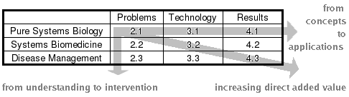
Figure 1. Organisation of this paper, reflecting the strategic road map from understanding to intervention, or from concepts to applications.
In section 2 we give a survey of challenging problems. In pure systems biology (2.1), systems biomedicine (2.2) and disease management (2.3). Section 3 deals with modern cutting edge technologies to tackle these problems, while finally in Section 4, we describe some achievements in software realizations. This paper is a descriptive one. More details, results and implementations can be found on our website mentioned in the heading of this paper, or in the references at the end, in which one can also find key references to other work and the literature.
2. challenging Problems
Similarly to systems/control theory, we can structure the problems of systems biology in three general groups: modeling, analysis and design to match desired properties.
2.1. Modeling in Pure Systems Biology
In systems biology pur sang, we look for mathematical models that adequately ‘summarize’ or ‘explain’ biological data. In accordance to the central dogma, where genes, defined as long ‘functional’ stretches of DNA, are first transcribed to mRNA, and subsequently translated to proteins, the modeling problem is typically decomposed and handled at each of these three levels separately, before a global, integrated description is proposed. In genomics the gene itself is studied, together with its sequence and functional elements that precede or follow the gene. An important task we have been tackling is the discovery of so- called ‘motifs’ – binding sites of transcription factors (Thijs et al, 2001; 2002; see also the survey paper: Tompa et al, 2005). The presence of such motifs can inform us on the nature of the signaling molecules that regulate the gene expression. The topology of the gene regulatory network can further be modeled based on dependencies in mRNA levels (Van den Bulcke et al., 2006b). The mRNA data is collected with microarray technology that assesses the amount of expressed mRNA of thousands of genes in parallel. This transcriptomics data is also the main input for the discovery of gene-condition bi-clusters (Sheng et al., 2003; Madeira and Oliveira, 2004). Such a bi-cluster contains genes with a similar expression profile under common conditions and is expected to be in one-to-one correspondence with functional modules in the gene regulatory network topology. The bridge between module and function is realized by the associated proteins. Recent advances in proteomics enable us now to profile the expression of thousands of proteins at once. An interesting problem is then the discovery of key players in tissue-specific protein-protein interaction networks. Here, one is challenged to account for the spatial nature of the data (Van de Plas et al, 2007).
In addition to the high-throughput data, there is also a vast amount of electronically accessible biomedical literature and lots of clinical and functional genomics data. We have therefore developed tools that take care of data integration: integrating data sources from a wide variety of origins (Van Vooren et al, 2007; Gevaert et al. 2006). Hence, data acquired in systems biology differ quite a lot from conventional data in systems/control theory. In (De Moor, 2003) we review some properties of these data and their consequences for subsequent inference. Many data sets consist for instance of a small number of samples (e.g., patients, order 100 to 1000), located in a high dimensional variable space (e.g., number of genes or proteins measured, order 1000 to 50000). This is further complicated by the low signal-to-noise ratio and a lack of standardization. Drilling down into the dispersed database entries of hundreds of biological objects is notably inefficient and shows the need for higher-level integrated views that can be captured more easily by an expert's mind. Capturing the paradoxical combination of huge diversity in biological systems on the one hand and their remarkable robustness on the other hand, is a tremendous challenge. Moreover, to deal adequately with the massively concurrent, stochastic interactions, systems biology searches for models that describe the mixture of signals with a sound probabilistic foundation. In practice, this boils down to models that describe a set of interdependent stochastic processes. The modeling task is then clearly an inverse problem and is often ill-posed. Stability of the solution is then taken care of by regularization.
2.2. Network Analysis for Systems Biomedicine
Gaining insight in genetic mechanisms does not end with modeling. In systems biomedicine, we analyze the models to find specific functional markers for diagnosis and targets for interventions. Such analysis is a must, since the large and complex knowledge representations leave many practical questions unanswered, prohibiting their direct usage in the clinic. The so-called futility theorem for instance states that many predicted motifs are in fact non-functional and thus only obscure the picture of tissue-specific gene regulation. When searching for disease genes, clinicians are similarly confronted with huge lists of interrelated candidate genes. Screening all possible candidate genes of a patient is a tedious and expensive task. Hence, clinicians look for adequate abstractions that are specifically directed to alleviate such subsequent derivations on tissue-specificity or pathology.
The analysis of these models is also quite different from what we do in systems theory. In the example of disease genes, a clinician wants the screening of genes to be alleviated by selecting only the most salient genes. Although not trivial, luckily for clinicians, biological systems seem to have evolved to an organization composed of functional modules that remain quite conserved among species and are built up dynamically according to environmental conditions (Qi and Ge, 2006). The problem of finding functional modules is then related to the question of feature selection over the genome of several species, of model reduction (cutting away less important side effects) and of determining which parameters in the model are most critical. The problem is also related, though certainly not equivalent, to selecting in systems/control theory which variables in a dynamical model will be observed and manipulated, such that the model becomes observable and controllable.
A pragmatic approach to decide which parts of the model we should make abstraction of and which belong to the functional module, is to use similarity measures. In prioritizing candidate disease genes, we can rank for instance candidates based on the similarity of their features with the features of carefully selected model or training genes. The underlying assumption is that candidate genes are expected to have similar properties as the genes already known to be associated with a biological process. These methods rely on the existing knowledge of the process, work well even with a small set of training genes, and do not need negative training samples. In the next section we show how to tackle the challenge of designing similarity measures that adequately mimic context-dependent functionality.
2.3. Design of Interventions in Disease Management
Due to the ongoing research results in systems biomedicine, more and more new markers and targets become available to the clinician. They can be used in the clinical management of genetic diseases such as heart failure, diabetes, cancer, dementia, and liver diseases, and will allow patient tailored therapy in the near future (Dollery et al., 2007). Currently the clinical management of for example cancer is only based on empirical data from the literature (clinical studies) or based on the expertise of the clinician. Cancer is a very complex process, caused by mutations in genes that result in limitless replication potential, evasion of cell death signaling, insensitivity to anti-growth signals, self-sufficiency in growth signals, sustained blood vessel development and tissue invasion (Hanahan and Weinberg, 2002). The inclusion of molecular markers, such as gene expression values from microarray data, would allow to tailor therapy to the patient since information on the genetic makeup of the patient’s tumor is then integrated in clinical management. Although it sounds promising, it remains a challenge to decide on medical interventions, based on the value of these markers, so that the patient’s condition will lie within a desired range.
In disease management research, tools are developed to support this medical decision making. Crucial intermediate steps in the solution process are diagnosis and prognosis. For diagnosis, which resembles the observer problem in conventional systems/control theory, disease management uses the markers from systems biomedicine and the model from pure systems biology and estimates the state of the patient. For prognosis, which resembles the simulation problem, it uses the targets from systems biomedicine together with the model to predict the effect of an intervention on the patient’s state. The non-linearity, stochasticity and time-variation of the models involved pose a huge challenge. The decision making itself, which resembles the control law in conventional systems/control theory, is usually still in hands of clinicians. Only in rare cases, disease management has succeeded in designing a fully automatic control law (Van Herpe et al., 2006), mainly using clinical information. The incorporation of genetic information (‘customized medicine’) in disease management is still a long way to go.
3. Cutting edge technology
In this section we address the challenges mentioned in the previous section and elaborate a bit more on solutions provided by technology.
3.1. Merging Data with Knowledge in Pure Systems Biology
The first step after experimental design deals with the typical low signal-to-noise ratio of the experimental data. Our own contributions reside mostly in the area of micro-array gene expression analysis, where we were involved in designing the current standard for reporting micro-array experiments (Minimum Information about a Micro-array Experiment, or MIAME) (Brazma et al., 2001) and storing/accessing gene expression data and analysis results (Durinck et al., 2004; Durinck et al., 2005). Based on insights in the biological process and measurement technology, we developed state of the art techniques for preprocessing and normalization, which removes consistent forms of measurement variation (Engelen et al., 2006; Allemeersch et al., 2006).
To tackle the modeling problem, systems biology trades ‘conventional’ statistical inference algorithms for techniques that originate in machine learning: They can better deal with small, high dimensional datasets. Such techniques heavily rely on prior knowledge of biological processes. Much research is done in the context of designing formal knowledge representations, or ontologies, that can capture the intricacies of a biological system as much as possible (Rubin et al, 2006). Most notable in this context is the Systems Biology Markup Language (SBML) (Hucka et al, 2004), a language to facilitate representation and sharing of models of biochemical reaction networks.
Many modeling algorithms in systems biology try to decompose signals according to some model sources. In (Alter et al., 2003) for instance, blind source separation techniques, such as the generalized singular value decomposition (De Moor, 1991), are used to find optimal deterministic signal sources in micro-array experiments. Other methods, such as change-point algorithms for motif discovery, add complicated noise models to the picture. Here, the background and motif sources are stochastic Markovian processes. The training DNA sequences can come from co-regulated genes of a single species (Thijs et al, 2001) or homologous genes from evolutionary related species (Monsieurs et al., 2006; Van Hellemont et al., 2005). For bi-clustering, methods were developed that separate signals by fitting a probabilistic mixture model over the gene-condition micro-array entries (Sheng et al. 2003; Dhollander et al., 2007). Finally, we successfully used decompositions such as principal component analysis (PCA) in a new, still developing technology, called imaging mass spectrometry, to separate spatio-biochemical trends in tissue and to reveal tissue-specific protein localization (Van de Plas et al., 2007) (figure 2). Often, one is not interested in a single separation, but in the posterior distribution over many. An interesting overview of algorithms that try to find optimal distributions as probabilistic graphical models can be found in (Frey BJ and Jojic N, 2005). It might then be computationally attractive to work with sample-based representations, as is done in Gibbs sampling for motif discovery (Thijs et al., 2002). To deal with the non-linearity of the models, for many blind source separation algorithms, such as PCA, ICA and CCA, also non-linear variants based on kernels were developed (Alzate et al., 2006).
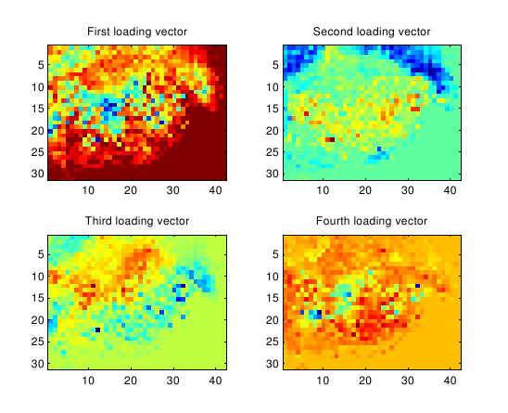
Figure 2. Four first spatial principal components of an imaging mass spectrometry analysis of rat spinal cord tissue (Van de Plas et al., 2007).

The integration of data from different sources provides an additional means to deal with high noise levels by reinforcing bona fide observations and reducing false negative predictions. More importantly, as each of the different experimental technologies provides a partial view of the involved cellular networks from a different perspective, combining them allows a more detailed and holistic representation of the underlying systems. This can solve the non-uniqueness of modeling solutions in systems biology, where modeling problems are often ill-posed. In recent years, a plethora of novel methods have been developed to reconstruct networks by integrating distinct data sources. Most existing methods make a prediction based on the independent analysis of a first data set and validate this prediction based on the results of the analysis of a complementary data set, so that they are analyzed sequentially and individually. A simultaneous analysis of coupled data might however be more informative. For this purpose, we developed Bayesian networks that integrate network topologies derived from several data sources (Gevaert et al., 2006).
3.2. Ranking Markers and Targets in Systems Biomedicine
In our search for functional modules, we focus on the development of probabilistic and statistical methods for the mining and integration of high-throughput and clinical data. Our goal is to identify key genes for the understanding, diagnosis and treatment of diseases. Therefore, various methods were developed that allow automated computational selection (or prioritisation) of candidate genes. As discussed above, one major challenge is to reconcile the various heterogeneous information sources that might shed some light on the disease-generating molecular mechanism. We approach this challenge using genetic algorithms, Bayesian networks, order statistics and kernel methods.
To bypass the mentioned futility theorem in motif discovery, we recall that functional motifs in eukaryotes appear in clusters (cis-regulatory modules). The associated transcription factors then collaborate. We developed a genetic algorithm that uses motif locations as input and selects an optimal group of collaborating, regulating genes (via motif models) to explain tissue-specificity of a group of genes (Aerts et al., 2004).
In (Gevaert et al, 2006) we used Bayesian networks to model the prognosis in breast cancer. A Bayesian network builds the joint probability distribution over a number of variables in a sparse way using a directed acyclic graphic. This model class allows to identify the variables that, when known, shield off the influence of the other variables in the network. This set of variables is called the Markov blanket. In (Gevaert et al, 2006) we showed that the Markov blanket consisted of only a limited set of clinical and gene expression variables. This results in a limited set of features that are necessary to predict a clinically relevant outcome, in this case the prognosis of breast cancer (see figure 3).
Another way to score candidate genes for their likeliness to be associated with disease is by defining how similar they are to known disease genes (the training genes). The similarity based approaches we devised use features like Gene Ontology annotations, Ensembl EST data, sequence similarity, InterPro protein domains, microarray gene expression data, protein-protein interaction data, etc. In order to reconcile all these data sources and derive a general measure of similarity, we use either order statistics (Aerts et al., 2006) or kernel-based methods (De Bie et al., 2007). With order statistics, we calculate the probability that a candidate gene’s features by chance are all as similar to the features of the training genes as observed (see figure 4). The lower this probability, the more probable it is that this candidate belongs to the set of training genes, i.e., has something to do with the biological process under study. Order statistics quite naturally solves the problem of missing data and reconciles even contradictory information sources. It allows for a statistical significance level to be set after multiple testing correction, thus removing any bias otherwise introducedduring prioritization by an expert. It also removes part of the bias towards known genes by including data sources that are equally valid for known and unknown genes. Even genes for which information from as few as 3 data sources is available, can receive a high ranking.
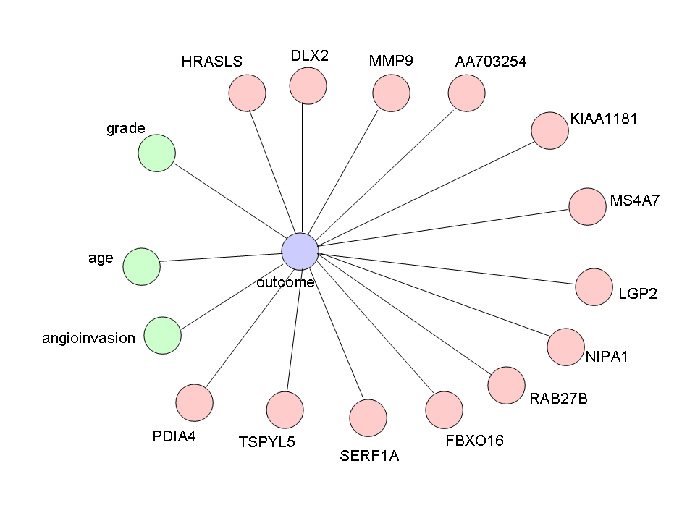Figure 3. The Markov blanket of a variable that describes the prognosis of breast cancer: a limited set of features are necessary to predict the clinically relevant outcome.

Our kernel-based methodology towards computational gene prioritization is comparable to approaches taken in novelty detection where a hyperplane is sought that separates the vector representations of the training genes from the origin with the largest possible margin. A candidate gene is considered more likely to be a disease gene if it lies farther in the direction of this hyperplane. The methodology differs from existing methods in that we take into account several different features of the genes under study, thus achieving true data fusion. After the knowledge in the different information sources is translated into similarities, the problem to optimally Figure 4. Endeavour methodology for training a disease model and scoring candidate genes according to their features’ similarity with the training genes.

integrate these different features can be reduced to an efficient convex optimisation problem. The resulting method is supported by strong statistical foundations, it is computationally very efficient, and empirically appears to perform extremely well.
3.3. Diagnosis and Prognosis in Disease Management
To tackle the prediction of diagnosis and prognosis of diseases we have also used machine learning methods such as Least Squares Support Vector Machines (LS-SVM). LS-SVM are a modified version of SVMs, where a linear set of equations is solved instead of a quadratic programming problem. This makes LS-SVM much faster on microarray data than SVM. We have succesfully applied these methods in a number of different applications, for example as an alternative to logistic regression (De Smet et al 2006b, Pochet and Suykens 2006) and as classification model for microarray data (Pochet et al 2005, De Smet et al 2006a).
The next step is to integrate complementary data sources. Many studies that investigate the use of microarray data to develop classifiers for prediction of diagnosis or prognosis in cancer, neglect the clinical data that is present. Clinical data, such as the patient’s history, laboratory analysis results, ultrasound parameters - which are the basis of day-to-day clinical decision support - are often underused or not used at all in combination with microarray data. We are developing algorithms based on kernel methods and Bayesian networks to integrate clinical and microarray data (Gevaert et al. 2006) and in the near future proteomics and metabolomics data as well.
4. SOME CASES and lots of software
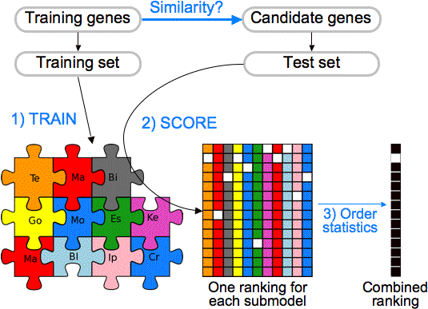
In this section we discuss some success stories that rely for their results on software implementations of the technologies mentioned above. More information can be found at the software section of the website http://www.kuleuven.be/bioinformatics/.
4.1. A Pipeline for Systems Biology
TOUCAN (Aerts et al., 2005) is a workbench for regulatory sequence analysis of metazoan genomes. It provides tools for comparative genomics, detection of significant transcription factor binding sites (e.g. MotifSampler and MotifScanner), and detection of cis-regulatory modules (e.g. ModuleMiner) in sets of coexpressed/coregulated genes. We have validated TOUCAN by analyzing muscle-specific genes, liver-specific genes and E2F target genes, and detected many known and unknown transcription factors (Aerts et al., 2003).
The motif information can be used in subsequent algorithms. In (Lemmens et al. 2006), we have developed the ReMoDiscovery algorithm for inferring transcriptional module networks from ChIP-chip (i.e. a bioassay that measures the binding of a regulator on possible target genes), motif and microarray data. The algorithm manages to discover transcriptional modules where target genes with a common expression profile also share the same regulatory program, based on evidence from ChIP-chip and motif data (figure 5).
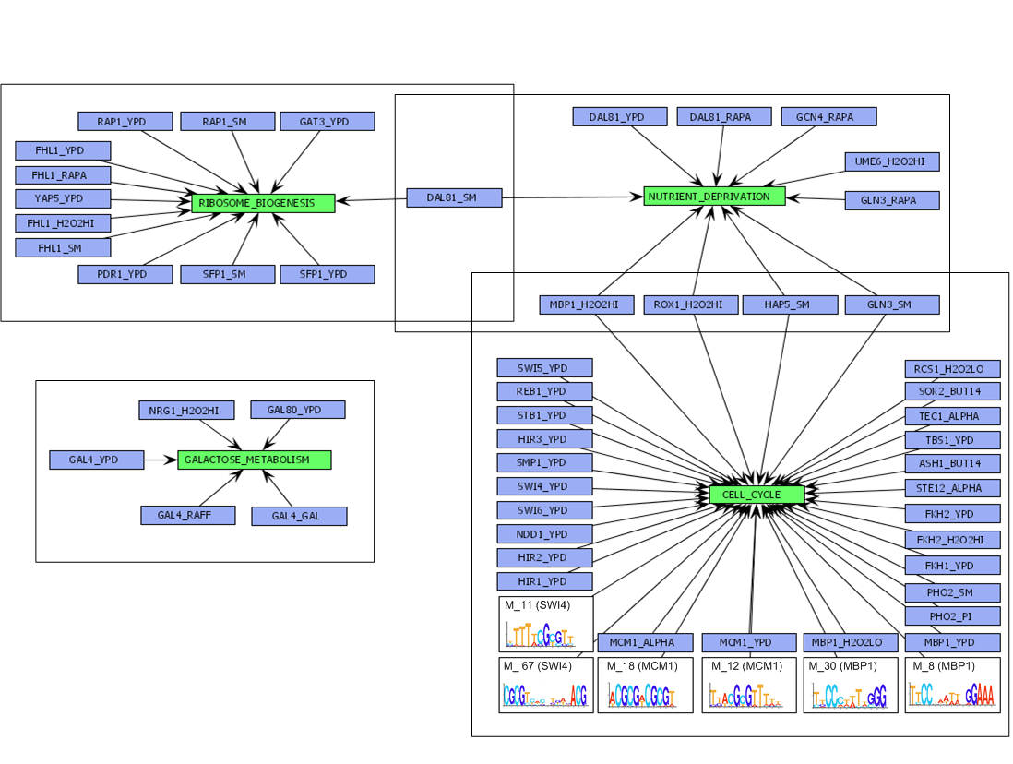
Figure 5. Overview of regulatory network modules identified in the Spellman dataset. For visualization, regulating genes of a module are grouped around a common function (Lemmens et al. 2006).

To enable the assessment of algorithms for the discovery of regulatory mechanisms in micro-array data, we have developed SynTReN (Van den Bulcke et al., 2006a), which is a generator of synthetic gene expression data for design and analysis of structure learning algorithms. The generated networks show statistical properties that are close to genuine biological networks. Inferring regulatory structures from micro-array data is an important research topic in bio-informatics. However since the true regulatory network is unknown, evaluating algorithms is challenging. With SynTReN we have shown significant deviations in performance between different algorithms for inference of regulatory networks (Van Leemput et al., 2006).
4.2. Systems Biomedicine's Endeavour
Based on the methods for gene prioritization described above, we have developed a freely available multi-organism computational prioritization framework called Endeavour (http://www.esat.kuleuven.be/endeavour).
This framework enables researchers to prioritize their own list of genes or to perform a full-genome scoring with respect to a carefully selected set of model genes (Aerts et al. 2006). Methodologies are available to find the most optimal set of training genes and information sources.
Endeavour was used to successfully identify a disease-related gene from a list of candidates linked to the DiGeorge syndrome (DGS), a congenital disorder in which abnormal development of the pharyngeal arch results in craniofacial dysmorphism. Linkage analyses revealed a 2-Mb deletion downstream of del22q11 in atypical DGS cases, but it was unknown which of the 58 genes in this region were involved in pharyngeal arch development. In this case, several different sets of training genes (models) were used, corresponding to different DGS symptoms (cardiovascular defects, cleft palate defects, neural crest cell anomalies). The gene YPEL1 consistently ranked first, as opposed to its ranking against training sets unrelated to DGS. Afterwards, the role of YPEL1 in pharyngeal arch development and in DGS was successfully established in vivo in a zebrafish model knock-down experiment (Aerts et al 2006).
4.3. Managing Diseases
In the context of disease management, we have developed a MicroArray Classification BEnchmarking Tool on Host server called M@CBETH (Pochet et al., 2005). This web service offers the microarray community a simple tool for making optimal two-class predictions. M@CBETH aims at finding the best prediction among different classification methods by using randomizations of the benchmarking dataset (Figure 8). These methods include LS-SVMs with linear and RFB kernel, and combinations of Fisher Discriminant Analysis and PCA (both normal and in kernel version). This tool allows to easily investigate a microarray data set (or any data set characterized by many variables) and to develop models for making a diagnosis or prognosis of disease.

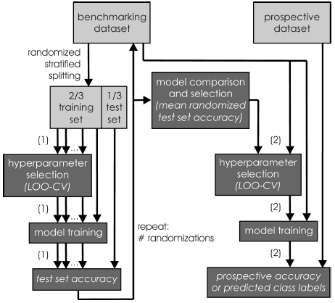

Figure 8. M@CBETH: graphical description of model training and selection (Pochet et al., 2005).

We also developed a tool for the diagnosis of chromosomal aberrations in congenital anomalies using comparative genomic hybridization microarrays (array CGH). This type of microarray consists of genomic DNA probes and allows to detect DNA copy number variations through deviations between samples. Mostly a reference design is used where a patient sample is analysed against a normal reference sample and copy number variations are detected through the deviation of signal intensity between patient and normal reference. However there are two major disadvantages of this setup: (1) the use of half of the resources to measure a (little informative) reference sample and (2) the possibility that deviating signals are associated to benign copy number variation in the “normal” reference, instead of a patient aberration. We proposed a new experimental design that compares three patients in three hybridizations (Patient 1 vs. Patient 3, Patient 3 vs. Patient 2, and Patient 2 vs. Patient 1). This experimental design addresses the two previously mentioned disadvantages and we were able to apply it successfully on a data set of 27 patients. The method is implemented as a web application and is available at www.esat.kuleuven.be/loop.
5. CONCLUSIONS
With this paper we hope to have given several examples of how the communities of control engineers and bio-informaticians can come together to tackle current research problems in biology and biomedicine. It is important to notice that the three research areas of interest to us (systems biology, systems biomedicine, and disease management) are much more interrelated than generally accepted, not only from a system identification point of view (which is obvious), but through the advent of high-througput genomics and proteomics technologies, also increasingly from a biotechnological point of view. As we approach the moment where the acquisition of an individual genome will only cost $1,000 or so, the added value of systems thinking can not be underestimated. Pharmaceutical drug discovery pipelines are drying up, but true personalized medicine and treatment is just around the corner, enabled by effective models of virtual patients (Alkema et al., 2006). One of the remaining challenges is how to connect biological information that is often descriptive, with the devised mathematical models on the one hand and the underlying biochemical reality on the other. In order to build accurate integrated biological models at several levels of detail, we will need to focus more on generating complementary data sets that shed light on different aspects of a biological system in a certain state and condition. The key focus in putting systems biology forward is on data integration and creation of uniform, scalable and easy-to-share systems views (Morris et al. 2005). To conclude, we would like to cite Leroy Hood from the Institute for Systems Biology in Seattle, who said in 2002, that ‘The Human Genome Project has catalyzed striking paradigm changes in biology - biology is an information science. [...] Systems biology will play a central role in the 21st century; there is a need for global (high throughput) tools of genomics, proteomics, and cell biology to decipher biological information; and computer science and applied math will play a commanding role in converting biological information into knowledge’.

ACKNOWLEDGEMENTS

Research supported by Research Council K.U.Leuven, Flemish Government, IWT, Belgian Federal Science Policy Office, EU. We would like to thank all our fellow researchers in the many projects we are involved in.
References
Aerts S., Thijs G., Coessens B., Staes M., Moreau Y., De Moor B. (2003). TOUCAN : Deciphering the Cis-Regulatory Logic of Coregulated Genes'', Nucleic Acids Research, 31(6), pp. 1753-1764.
Aerts S., Van Loo P., Moreau Y., De Moor B. (2004). A genetic algorithm for the detection of new cis-regulatory modules in sets of coregulated genes. Bioinformatics, 20(12), pp. 1974-1976.
Aerts S, Van Loo P, Thijs G, Mayer H, de Martin R, Moreau Y, De Moor B. (2005). TOUCAN 2: the all-inclusive open source workbench for regulatory sequence analysis. Nucleic Acids Res, 33(Web Server issue), W393-6.
Aerts S, Lambrechts D, Maity S, Van Loo P, Coessens B, De Smet F, Tranchevent LC, De Moor B, Marynen P, Hassan B, Carmeliet P, Moreau Y. (2006). Gene prioritization through genomic data fusion. Nat Biotechnol, 24(5), 537-44.
Alkema W, Rullmann T, van Elsas A. (2006) Target validation in silico: does the virtual patient cure the pharma pipeline? Expert Opin Ther Targets, 10(5), 635-8.
Allemeersch J., Statistical analysis of microarray data: Applications in platform comparison, compendium data, and array CGH. (2006) PhD thesis, Faculty of Engineering, K.U.Leuven, Leuven, Belgium.
Alter O, Brown PO and Botstein D (2003). Generalized Singular Value Decomposition For Comparative Analysis of Genome-Scale Expression Datasets of Two Different Organisms. Proceedings of the National Academy of Sciences 100 (6), pp. 3351–3356
Alzate C., Suykens J. A. K. (2006). A Weighted Kernel PCA Formulation with Out-of-Sample Extensions for Spectral Clustering Methods'', Proc. of the 2006 International Joint Conference on Neural Networks (IJCNN'06), pp. 138-144.
Ben-Tabou de-Leon S, Davidson EH. (2006). Deciphering the underlying mechanism of specification and differentiation: the sea urchin gene regulatory network. Sci STKE. Nov 14;2006(361):pe47.
Brazma A, Hingamp P, Quackenbush J, Sherlock G, Spellman P, Stoeckert C, Aach J, Ansorge W, Ball CA, Causton HC, Gaasterland T, Glenisson P, Holstege FC, Kim IF, Markowitz V, Matese JC, Parkinson H, Robinson A, Sarkans U, Schulze-Kremer S, Stewart J, Taylor R, Vilo J, Vingron M. (2001). Minimum information about a microarray experiment (MIAME)-toward standards for microarray data. Nat Genet, 29(4), 365-71.
De Bie T, Tranchevent LC, van Oeffelen L, Moreau Y (2007). Kernel-based data fusion for gene prioritization. Bioinformatics, in press.
Dhollander T., Sheng Q., Lemmens K., De Moor B., Marchal K., Moreau Y. (2007). Query-driven module discovery in microarray data. submitted
De Moor B (1991) Generalizations of the singular value and the QR decomposition. Signal Processing, 25(2), pp. 135-146.
De Moor B., Marchal K., Mathys J., Moreau Y. (2003). Bioinformatics : Organisms from Venus, Technology from Jupiter, Algorithms from Mars. European Journal of Control, 9(2-3), pp. 237-278.
De Smet F., Pochet N., Engelen K., Van Gorp T., Van Hummelen P., Marchal K., Amant F., Timmerman D., De Moor B., Vergote I. (2006a). Predicting the clinical behavior of ovarian cancer from gene expression profiles. International Journal of Gynecological Cancer, 16(1), pp. 147-151
De Smet F., De Brabanter J., Konstantinovic M.L., Pochet N., Van den Bosch T., Moerman P., De Moor B., Vergote I., Timmerman D. (2006b). New models to predict depth of infiltration in endometrial carcinoma based on transvaginal sonography. Ultrasound in Obstetrics and Gynecology, 27(6), pp. 664-671
Dollery C, Kitney R, Challis R, Delpy D, Edwards D, Henney A, Kirkwood T, Noble D, Rowland M, Tarassenko L, Williams D, Smith L, Santoro L (2007). Systems Biology: a vision for engineering and medicine. Report of the Royal Academy of Engineering and Academy of Medical Sciences.
Durinck S, Allemeersch J, Carey VJ, Moreau Y, De Moor B. (2004). Importing MAGE-ML format microarray data into BioConductor. Bioinformatics, 20(18), 3641-2.
Durinck S, Moreau Y, Kasprzyk A, Davis S, De Moor B, Brazma A, Huber W. (2005). BioMart and Bioconductor: a powerful link between biological databases and microarray data analysis. Bioinformatics, 21(16), 3439-40.
Engelen K., Naudts B., De Moor B., Marchal K. (2006). A calibration method for estimating absolute expression levels from microarray data. Bioinformatics, 22(10), pp. 1251-8.
Faguet GB (2006). The War on Cancer: An anatomy of failure, A blueprint for the future. Springer.
Frey BJ and Jojic N (2005) A Comparison of Algorithms for Inference and learning in Probabilistic Graphical Models. IEEE Transactions on Pattern Analysis and Machine Intelligence, 27 (9).
Gevaert O., De Smet F., Timmerman D., Moreau Y. and De Moor B. (2006). Predicting the prognosis of breast cancer by integrating clinical and microarray data with Bayesian networks, Bioinformatics, ISMB 2006 Conference Proceedings, 22(14), pp. e184-e190
Hanahan D, Weinberg RA (2000). The hallmarks of cancer. Cell, 7;100(1):57-70
Hucka M, Finney A, Bornstein BJ, Keating SM, Shapiro BE, Matthews J, Kovitz BL, Schilstra MJ, Funahashi A, Doyle JC, Kitano H. (2004). Evolving a lingua franca and associated software infrastructure for computational systems biology: the Systems Biology Markup Language (SBML) project. Syst Biol (Stevenage), 1(1), 41-53.
Lemmens K., Dhollander T., De Bie T., Monsieurs P., Engelen K., Smets B., Winderickx J., De Moor B., Marchal K. (2006). Inferring transcriptional module networks from ChIP-chip-, motif- and microarray data. Genome Biology, 7(5), pp. R37
Madeira SC and Oliveira AL (2004) Biclustering algorithms for biological data analysis: a survey. IEEE Transactions on Computational Biology and Bioinformatics, 1(1).
Monsieurs P., Thijs G., Fadda A., De Keersmaecker S.,
Vanderleyden J., De Moor B., Marchal K (2006). More robust detection of motifs in coexpressed genes by using phylogenetic information. BMC Bioinformatics, 20, 7(1).
Morris R.W., Bean C.A., Farber G.K., Gallahan D., Jakobsson E., Liu Y., Lyster P.M., Peng G.C., Roberts F.S., Twery M., Whitmarsh J., and Skinner K. (2005). Digital biology: an emerging and promising discipline. Trends Biotechnol, 23(3):113–117.
Pochet N.L.M.M., Janssens F.A.L., De Smet F., Marchal K., Suykens J.A.K., De Moor B.L.R. (2005). M@CBETH: a microarray classification benchmarking tool. Bioinformatics, 21(14), pp. 3185-3186
Pochet N.L.M.M., Suykens J.A.K. (2006). Support vector machines versus logistic regression: improving prospective performance in clinical decision-making. Ultrasound in Obstetrics & Gynecology, Opinion, 27(6), pp. 607-608
Qi Y, Ge H (2006). Modularity and dynamics of cellular networks. PLoS Computational Biology, 2(12).
Rubin DL, Lewis SE, Mungall CJ, Misra S, Westerfield M, Ashburner M, Sim I, Chute CG, Solbrig H, Storey MA, Smith B, Day-Richter J, Noy NF, Musen MA. (2006). National Center for Biomedical Ontology: advancing biomedicine through structured organization of scientific knowledge. OMICS, 10(2), 185-98.
Sheng Q., Moreau Y., De Moor B. (2003). Biclustering Microarray data by Gibbs sampling. Bioinformatics, ECCB 2003 Proceedings, 19, pp. ii196-ii205
Thijs G., Lescot M., Marchal K., Rombauts S., De Moor B., Rouze P., Moreau Y. (2001). A higher-order background model improves the detection by Gibbs sampling of potential promoter regulatory elements, Bioinformatics, 17(12), Dec. 2001, pp. 1113-1122
Thijs G., Marchal K., Lescot M., Rombauts S., De Moor B., Rouze P., Moreau Y. (2002). A Gibbs sampling method to find over-represented motifs in the upstream regions of co-expressed genes. Journal of Computational Biology, Special Issue RECOMB'2002, 9(3),pp. 447-464.
Tompa M., Li N., Bailey T.L., Church G.M., De Moor B., Eskin E., Favorov A.V., Frith M.C., Fu Y., Kent J.W., Makeev V.J., Mironov A.A., Noble W.S., Pavesi G., Pesole G., Régnier M., Simonis N., Sinha S., Thijs G., van Helden J., Vandenbogaert M., Weng Z., Workman C., Ye C., Zhu Z., ``An Assessment of Computational Tools for the Discovery of Trans-cription Factor Binding Sites'', Nature Biotechnology, vol. 23, no. 1, Jan. 2005, pp. 137-144.
Van den Bulcke T., Van Leemput K., Naudts B., van Remortel P., Ma H., Verschoren A., De Moor B., Marchal K. (2006a). SynTReN: a generator of synthetic gene expression data for design and analysis of structure learning algorithms. BMC Bioinformatics, 7(43)
Van den Bulcke T., Lemmens K., Van de Peer Y., Marchal K. (2006b). `Inferring Transcriptional Networks by Mining ‘Omics’ Data. Current Bioinformatics, 1(3), pp. 301—313
Van de Plas R., Ojeda F., Dewil M., Van Den Bosch L., De Moor B., Waelkens E. (2007). Prospective Exploration of Biochemical Tissue Composition via Imaging Mass Spectrometry Guided by Principal Component Analysis. Proceedings of the Pacific Symposium on Biocomputing 12 (PSB), Maui, Hawaii, pp. 458-469
Van Hellemont R., Monsieurs P., Thijs G., De Moor B., Van de Peer Y., Marchal K. (2005). A novel approach to identifying regulatory motifs in distantly related genomes. Genome Biology, 6, pp. R113.1-R113.19.
Van Herpe T., Espinoza M., Pluymers B., Goethals I., Wouters P., Van den Berghe G., and De Moor B. (2006). An adaptive input–output modeling approach for predicting the glycemia of critically ill patients. Physiological Measurement, 27, pp. 1057-1069
Van Leemput D., Van den Bulcke T., Dhollander T., De Moor B., Marchal K., van Remortel P. (2006). Exploring the operational characteristics of inference algorithms for transcriptional networks by means of synthetic data. Accepted for publication in Artificial Life.
Van Vooren S., Thienpont B., Menten B., Speleman F., De Moor B., Vermeesch J. R., Moreau Y. (2007). Mapping Biomedical Concepts onto the Human Genome by Mining Literature on Chromosomal Aberrations, Nucleic Acids Research, vol. Advance Access, no. 10.1093/nar/gkm054, pp. 1-11
Wolkenhauer O (2001). Systems biology: the reincarnation of systems theory applied in biology? Brief Bioinformatics, 2(3):258-70.

* To whom all correspondence should be addressed
GOA AMBioRICS, CoE EF/05/007 SymBioSys, several PhD/postdoc & fellow grants
FWO: PhD/postdoc grants and several projects G.0407.02 (support vector machines), G.0413.03 (inference in bioi), G.0388.03 (microarrays for clinical use), G.0229.03 (ontologies in bioi), G.0241.04 (Functional Genomics), G.0499.04 (Statistics), G.0232.05 (Cardiovascular), G.0318.05 (subfunctionalization), G.0553.06 (VitamineD), G.0302.07 (SVM/Kernel), research communities (ICCoS, ANMMM, MLDM)
PhD Grants, GBOU (McKnow-E (Knowledge management algorithms); SQUAD (quorum sensing); ANA (biosensors)), TAD-BioScope-IT, IWT-Silicos, SBO-BioFrame
IUAP P6/25 (BioMaGNet, Bioinformatics and modeling: from Genomes to Networks, 2007-2011)
EU-RTD (ERNSI: European Research Network on System Identification), FP6-NoE Biopattern, FP6-IP e-Tumours, FP6-MC-EST Bioptrain

