EVALUATION OF RIVER FLOOD REGULATION BY MEANS OF MODEL PREDICTIVE CONTROL
P. Willems¹, T. Barjas Blanco², P-K. Chiang¹, K. Cauwenberghs³, J. Berlamont¹ and B. De Moor²
- Katholieke Universiteit Leuven, Department of Civil Engineering, Kasteelpark Arenberg 40, BE-3001 Leuven,Belgium (E-mail: Patrick.Willems@bwk.kuleuven.be; Jean.Berlamont@bwk.kuleuven.be)
- Katholieke Universiteit Leuven, Department of Electrotechnical Engineering, Kasteelpark Arenberg 10, BE-3001 Leuven, Belgium (E-mail: Toni.barjas-blanco@esat.kuleuven.be; Bart.DeMoor@esat.kuleuven.be)
- Flemish Environment Agency (VMM), Division Water, Koning Albert-II laan 20, BE-1000 Brussels, Belgium (E-mail: k.cauwenberghs@vmm.be)
Abstract: Real-time regulation of flood control reservoirs is being researched for the case of the river Demer in Belgium. Model Predictive Control (MPC) has been tested as technique for the most optimal regulation of the hydraulic structures that control the reservoir storage in order to minimize the flood risk given the available reservoir storage capacity. However, before MPC could be implemented for this application, solutions to a number of difficulties had to be searched. These difficulties were related to the highly non-linear response of the water system to rainfall and rainfall-runoff, to the strong time variability of the state variables in the system, to discontinuous changes in the state variables, to uncontrollable variables in the system, and due to multiple regulation objectives and priorities.
It was found based on the simulation of the historical flood events of 1998 and 2002 that after solving these problems MPC is found powerful to regulate flood control reservoirs in a more efficient way. The regulation objectives could be reached, while this was not the case for the current regulation based on fixed regulation rules by the local water authority. The same conclusions were obtained after simulation of two severe flood events with short recurrence interval. It is shown that the MPC controller developed for the River Demer basin in Belgium has a high flexibility to implement combined regulation strategies (regulation objectives for different types of variables, i.e. river and reservoir levels, and at different locations), and taking into account the regulation priorities set by the water authority.
Key Words: flood; real-time control; reservoir

introduction
In a research project for the Flemish Environment Agency, the application of automatic and intelligent techniques is researched for the operation of flood control reservoirs. The aim of the project is to develop an algorithm that can be applied for the future regulation of the hydraulic structures that control the reservoirs’ storage. The current regulation by the regional water authority is based on fixed rules. These depend on monitored water levels at critical locations along the main rivers. The reservoirs start to fill when one of these water levels reaches the “warning level”. The filling will continue till a first storage level is reached. Afterwards, the river level(s) can further increase till the “alarm level”. When this level is reached in any of the critical locations considered, the reservoir filling continues up to a second maximum storage level. The warning levels, the alarm levels, and the reservoir storage levels are taken fixed, and do not change depending on event-specific conditions or predictions on future conditions. It is, however, expected that the efficiency of the flood control can be increased when these event-specific and predicted future conditions are taken into account, and that, consequently, floods can be managed in a more cost-effective way.
The study case involves two existing flood control reservoirs along the river Demer in Belgium, upstream of the cities of Diest and Aarschot. The city of Diest experienced very severe flooding in September-October 1998. For the river Demer basin, the Flemish Environment Agency developed a full hydrodynamic model for the main rivers, implemented in the InfoWorks-RS software. The model is linked with lumped conceptual rainfall-runoff models (PDM models) for all subcatchments in the basin. Rainfall input estimates for these models are based on 15 minutes rainfall intensities by a large number of recording rain gauges. The InfoWorks-RS model recently was extended with a real-time flood forecasting model, implemented in the FloodWorks software of Wallingford Software Ltd. The flood forecasting is based on rainfall forecasting, both on the short term based on radar data and on the long term based on weather predictions by the Royal Meteorological Institute of Belgium. A data assimilation technique updates the model in real-time (with 15 min time step during the critical high flow periods) correcting the model outputs to water level measurements at various locations along the river network.
In order to develop the real-time flood control algorithm for this study region, the authors decided to make use of the Model Predictive Control (MPC) technique. This technique is currently in use for a large number of control applications in different disciplines (Camacho, 1999; Rossiter, 2000). Best-known application in this respect is the control of chemical reactors. In comparison with other, more traditional, control techniques (see e.g. Malaterre et al., 1998; Burt et al., 1998; Brian and Albert, 2002; Litrico et al., 2006), MPC is an advanced control technique, which has some interesting advantages. First advantage is that it can account for constraints (i.e. upper and lower limits of the gate heights at the hydraulic regulation structures, maximum movement speed of the gates, maximum and minimum storage levels of the flood control reservoirs, flood levels along the river system, etc.). The technique can also account for predicted future states of the system (i.e. real-time forecasting results), and for multiple regulation objectives (i.e. flood levels at different locations along the river) and priorities (i.e. first reservoir filling after warning levels, second filling after alarm levels). Application of MPC to river systems has, however, - in comparison with other applications - many difficulties:
- The river system including the flood control reservoirs has a highly non-linear response to the predicted model input. River discharges and water levels and reservoir levels indeed are related to rainfall and rainfall-runoff is a highly non-linear way.
- The system is highly time variable. This means that the values around which the variables describing the state of the system vary, are not fixed but strongly change in time (the so-called “working point” in control theory is not fixed). Also the flood control levels might change in time, e.g. depending on whether warning or alarm levels are reached. Also these conditions differ from the assumptions most often considered in control theory.
- The system shows some discontinuous changes in the state variables (i.e. closed or open gate, flooding or no flooding).
- The regulation objectives and priorities are multiple (regulation at different locations, and with interactions between model results at these locations).
These difficulties were addressed in the first phase of the research. Solutions were searched in order to overcome the difficulties. This was done based on a simple test case, selected from the full case study of the river Demer. The simple test case focuses on the reservoir called “Schulensmeer”. A reduced and simplified model has been derived from the InfoWorks-RS model of the full Demer basin. In order to reduce model computational times, a reservoir-based conceptual model has been developed for the study area. The conceptual model structure was identified and the model parameters calibrated to the more detailed full hydrodynamic InfoWorks model. The conceptual model has been used within the MPC real-time control procedure.

HYDRODYNAMIC WATER SYSTEM MODELLING
Figure 1 shows the scheme of the InfoWorks model components for the study area around the two flood control reservoirs “Schulensmeer” and “Webbekom” in the river Demer basin. This area receives rainfall-runoff inflow via the tributary rivers Mangelbeek, Herk, Gete, Velpe, Zwartebeek, Zwartewater and Begijnenbeek. By means of the hydraulic regulating structures A and K7, the local water engineers can anticipate on future flood risks. Through closing gate K7 and opening gate A, the Schulensmeer reservoir is being filled, the downstream Demer flow reduced, and consequently the flood risk of the cities Diest and Aarschot downstream of the study area of the reservoirs reduced. After the flood period, the Schulensmeer reservoir (which consists of different reservoir compartments) can be emptied through the hydraulic regulating structures D and E. The second reservoir “Webbekom” is regulated in a similar way by means of the hydraulic structures K18, K19, K7 at the Leugebeek river, K24* and K30. This paper describes the results of the first phase of the research, which focused on the reduced study area around the “Schulensmeer” reservoir. Figure 2 shows the scheme of the conceptual model developed for this reduced area. The river reaches are in this scheme represented by means of lines with positive flow in the direction of the arrows, the hydraulic regulating structures by means of the rectangles, and the model units where water storage (in the reservoir compartments or along river reaches) and water levels are simulated by nodes. The symbol “q” denotes discharges, “h” water levels, “v” storage volumes, and “k” controllable gate crest levels. The water levels and volumes are the model variables describing the state of the water system in the MPC controller. The gate crest levels are in the inputs in the MPC controller, the upstream (rainfall-runoff) discharges the disturbances of the MPC controller.
The conceptual model is of the reservoir-type. The structure of this model (type of reservoir, or storage-outflow and/or storage/inflow equations) is identified and the model parameters calibrated based on simulation results with the full hydrodynamic InfoWorks model. The storage nodes simply describe the water volume after closing the water balance. The discharge through the river reaches is modeled based on the up- and downstream water levels. For most river reaches, the discharge in the reach depends on the upstream water level or storage volume using a monotonously increasing equation. This equation was identified and the parameters calibrated based on simulation results derived from the full hydrodynamic model (for two historical high flow or flood events: the flood events of September 1998 and January 2002). The procedure of Vaes et al. (2002) for identification and calibration of reservoir-based storage-throughflow relationships was followed. The hydraulic structure equations are taken equal to the ones of the InfoWorks model. Of course, also validation of both the InfoWorks and the conceptual model to available hydrometric data was made. Both models have a time step of 5 minutes, but model output results were aggregated at the hourly time step. The conceptual model has been simplified in comparison with the real configuration of the entire system: no flood comportments were considered and the reservoir is emptied directly to the river Demer (no gate E or no downstream drainage canals). The upstream model components and model variables are shown in the photos of Figure 3.

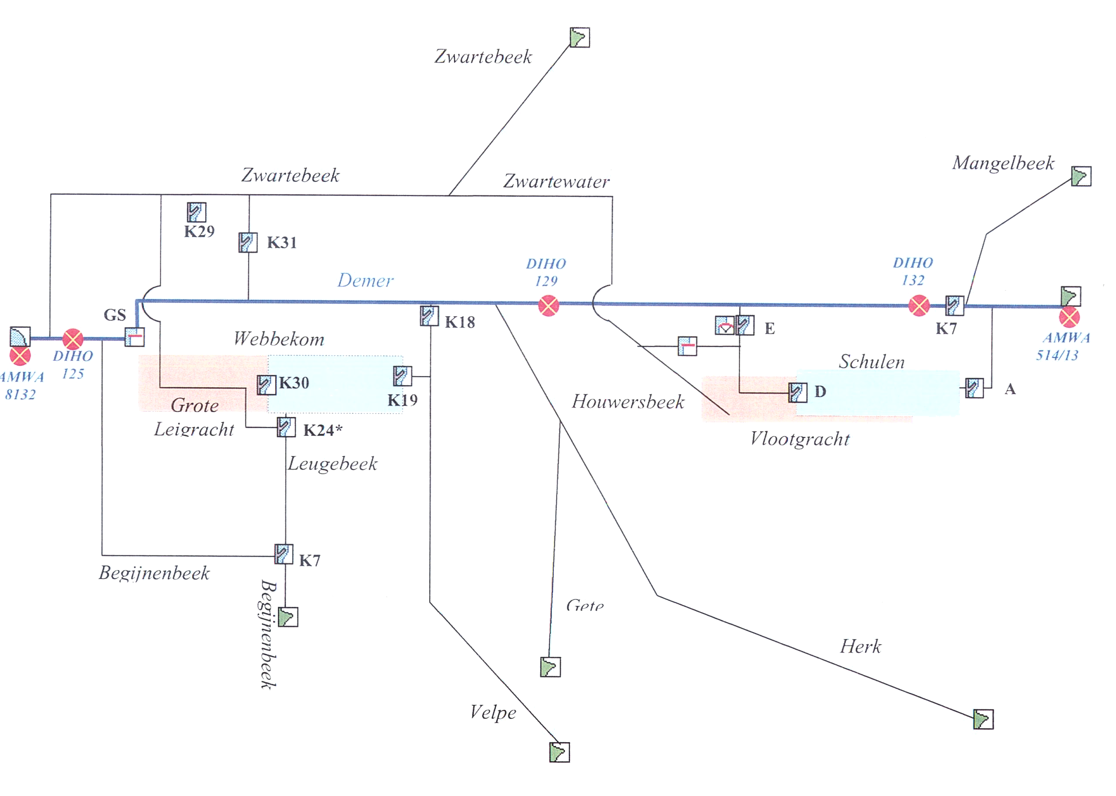
Figure 1: Scheme of the river network in the study area, the flood control reservoirs “Webbekom” and “Schulensmeer” at the village Schulen, and the hydraulic regulating structures (OBM-Demer, 2003)

Figure 2: Conceptual model structure of the reduced and simplified study area of the “Schulensmeer” flood control reservoir
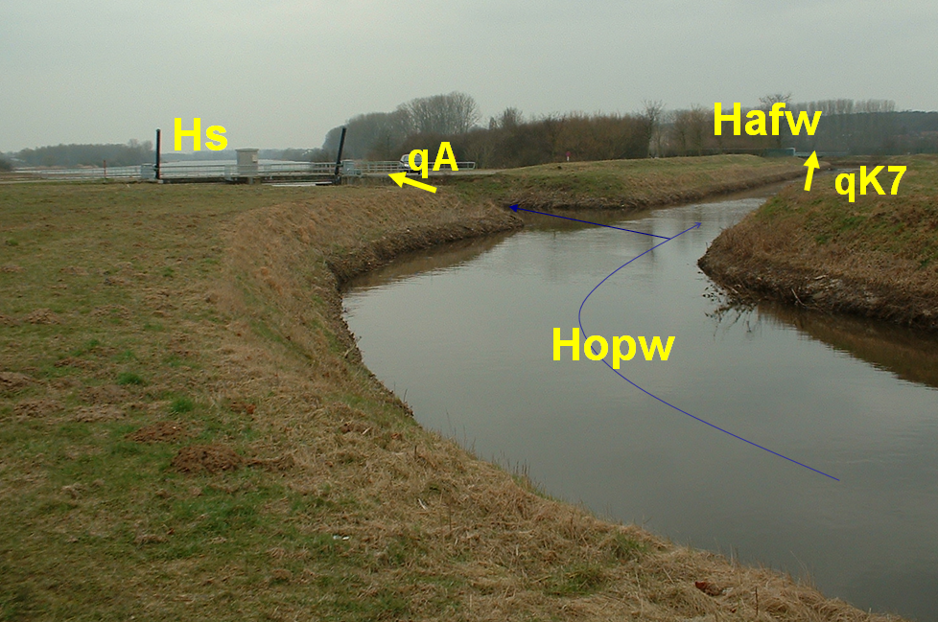

Figure 3: Photo of the river Demer and the “Schulensmeer” flood control reservoir in the background, together with the locations of the main water level and discharge variables

REAL-TIME FLOOD CONTROL
The MPC technique was applied to control the gate crest levels of the hydraulic regulating structures (the inputs of the controller) such that the model prediction results (the outputs of the controller) are closest to specified objectives. In order to do so, cost- and objective-functions are defined. The MPC algorithm will determine the inputs of the controller such that the model outputs come closest to the reference values (the objectives) is the shortest time. This will be done in a model-based way, starting from the knowledge on the current state of the system, and the model predictions on the future states. These model predictions are based on predicted future rainfall intensities over the catchment. Short-term rainfall predictions (6h ahead) are based on extrapolations of radar images; long-term predictions (5 days ahead) by the Royal Meteorological Institute of Belgium. In the FloodWorks model (which is the extension of the InfoWorks model with a real-time flood forecasting module), a data assimilation technique is applied to correct/update the model states and outputs based on available river water level measurements at several locations in the basin.
The MPC algorithm thus requires an optimization problem to be solved. It also introduces feedback in the system, such that model output changes as a result of disturbances (i.e. increased rainfall intensities or rainfall-runoff discharges) and model errors due to modelling uncertainties can be accounted for.
In this first phase of the research project, some technical problems had to be solved first. The application of MPC to river systems indeed has - in comparison with other applications - many difficulties, as already outlined in the introduction: the system has a highly non-linear response, it is highly time variable, it shows some discontinuous changes in the state variables, and the regulation objectives and priorities are multiple. In addition to these problems, it has been detected that some states of the gates were uncontrollable due to the fact that at low water levels the discharge released by the hydraulic structure was modelled independently on the up- and/or downstream water levels.
The problem of the highly non-linear model structure has been solved by applying the technique of iterative multiple linearization (e.g. Allgöwer et al., 1999). The problem of discontinuous changes in the state variables (caused by the if-then-else model structure for specific submodels) and the problem of uncontrollable model states was solved by using a ‘fuzzy control’ model. The multiple regulation objectives (different variables and locations, reference levels versus minimum and warning/alarm levels, different priorities, and other preferences by the water authority) could be implemented through a smart adjustment of the cost- and objective function of the MPC controller. After implementation is was found that calculation times of the controller were very high. They, however, could be reduced by selecting more efficient optimization algorithms.

Regulation objectives and priorities
The regulation objectives and priorities considered in this study were defined by the local water authority. During normal river flow conditions (non-flooding conditions), the upstream water level along the Demer river needs to be kept constant at 21.5 m above the mean sea level (a.m.s.l.). Also during these conditions, the Schulensmeer reservoir was emptied at the highest possible rate. Strict constraints to be considered are the minimum and maximum gate crest levels at the hydraulic regulating structures. The current fixed regulation makes use of warning and alarm levels at various locations along the river network. When the warning levels are exceeded, the reservoir will be filled till a first storage level. Afterwards, the river water levels are allowed to further increase till the alarm levels, where after the reservoir is completely filled. For the current MPC-regulation, same regulation priorities were implemented.
Figure 4: Simulation results for the historical flood of September 1998; (top) for the current fixed regulation, (bottom) after MPC real-time control

Results
Figures 4 and 5 show the results of the current fixed regulation, as implemented in the model, and the comparison with the results after MPC regulation. Figure 6 shows the results for the largest recent historical flood event of September 1998. It is clear in this plot that during the first 250 hours, the MPC controller indeed succeeds to regulate the upstream Demer river levels to the reference value of 21.5 m a.m.s.l. During the high flow or flood conditions, the Demer water levels could be kept limited to the flood level of 23 m a.m.s.l. upstream of hydraulic structure K7 and to the flood level of 22.75 m a.m.s.l. downstream of K7. This does not happen at the expense of an increased storage of the Schulensmeer reservoir, because the reservoir level is limited to the maximum reservoir level of 23.10 m a.m.s.l. After the high flow or flood event, the Schulensmeer reservoir is emptied in a way quicker than during the current regulation. The improved regulation by the MPC controller thus is explained by the quicker flow release to the downstream demer reach shortly after the flood, as well as due to additional storage of water (i.e. upstream in the river Demer bed) just before or after the flood period.
To investigate whether the MPC controller can anticipate to predicted future flood conditions, the severe historical flood event of 1998 was on the basis of Figure 5 simulated twice with a limited time span between the two events. The figure shows that also during the second flood event, upstream Demer levels and reservoir levels are limited to the flood level of 23 m a.m.s.l. This could be done by additional release of water to the downstream Demer reach during the time span in between the two events, taking into account the predicted second flood event during the time horizon considered for the MPC controller.
Figure 5: Simulation results for a fictitious flood event based on two successive Sept. 1998 flood events; (top) for the current fixed regulation, (bottom) after MPC real-time control

CONCLUSIONS
On the basis of the simulation of the historical flood events of 1998 and 2002, it has been shown in this paper that MPC control is a powerful technique in order to regulate flood control reservoirs in a more efficient way. The regulation objectives could be reached, while this was not the case for the current regulation based on fixed regulation rules by the local water authority. The same conclusions were obtained after simulation of two severe flood events with short recurrence interval. It is shown that the MPC controller developed for the River Demer basin in Belgium has a high flexibility to implement combined regulation strategies (regulation objectives for different types of variables, i.e. river and reservoir levels, and at different locations), and taking into account the regulation priorities set.
During the next phase of the research project, the MPC control technique will be further investigated by implementing the technique for the entire study area of Figure 1. This study area includes the outer areas of the Schulensmeer reservoir, the second reservoir at Webbekom and the interactions with several river tributaries of the Demer. By means of this implementation, it will be tested whether the MPC control technique can handle a more complex water system, with much more model variables and regulation priorities, and with much higher model calculation times. This case will also have more interactions between the different model components (variables, meeting one objective might lead to failure of another objective at another location).
Future research will also focus on increasing the computational speed of the controller, such that it can work in an operational environment where real-time control might be needed with time steps of around 15 minutes. It will also be tested whether a “free” regulation (without prior defined regulation priorities) might work and could lead to a more efficient regulation. This would require a global objective function to be defined (combining the different objectives in one single global objective measure, e.g. based on minimizing the overall flood damage in the basin).

ACKNOWLEDGEMENTS
The research project is funded by the Division Water (Afdeling Water) of the Flemish Environment Agency (VMM) in Belgium. Also the full hydrodynamic InfoWorks-RS model of the river Demer basin, as well as the hydrometric calibration data, were provided by this regional water authority.

References
Allgöwer, F., Badgwell, T.A., Qin, J.S., Rawlings, J.B., and Wright, S.J., 1999. Nonlinear Predictive Control and Moving Horizon Estimation - Introductory Overview. Advances in Control, Highlights of ECC'99, Springer, 391-449.
Brian, T.W., and Albert, J.C., 2002. Performance of Historic Downstream Canal Control Algorithms on ASCE Test Canal 1. Journal of Irrigation and Drainage Engineering 128: 365-375.
Burt, C.M., Mills, R.S., Khalsa, R.D., and Ruiz, V. 1998. Improved Proportional-Integral (PI) Logic for Canal Automation. Journal of Irrigation and Drainage Engineering 124: 53-57.
Camacho, E. F., and Bordons, C. 1999. Model Predictive Control. Springer, London.
Litrico, X., Fromion, V., and Baume, J.-P., 2006. Tuning of Robust Distant Downstream PI Controllers for an Irrigation Canal Pool - II. Implementation Issues. Journal of Irrigation and Drainage Engineering 132: 369-379.
Malaterre, P.-O., Rogers, D.C., Schuurmans, J., 1998. Classification of Canal Control Algorithms. Journal of Irrigation and Drainage Engineering 124: 3-10.
OBM-Demer, 2003. Operational river basin model Demer – Technical documentation v.2.0 (in Dutch), Flemish Environment Agency, Aalst, Belgium.
Rossiter, J. A. 2000. Model predictive control: A Practical Approach. CRC Press.
Vaes, G., Willems P., and Berlamont, J. 2002. The use of reservoir models for the assessment of the input from combined sewer overflows into river models, 9th Intern. Conference on 'Urban Drainage', Portland, 8-13 September 2002, CD-ROM proceedings: 16 p.

