Detection of cis-acting regulatory elements in plants:
a Gibbs sampling approach

G. Thijs⁽¹⁾, S. Rombauts ⁽²⁾, M. Lescot ⁽¹⁾, K. Marchal ⁽¹⁾, B. De Moor ⁽¹⁾, Y. Moreau ⁽¹⁾, and P. Rouzé ⁽³⁾

¹SISTA/COSIC-ESAT, KULeuven, Kardinaal Mercierlaan 94, 3001 Heverlee

²Department of Plant Genetics, VIB, University of Gent, Ledeganckstraat 35, 9000 Gent

³INRA associated laboratory, VIB, University of Gent, Ledeganckstraat 35, 9000 Gent

gert.thijs@esat.kuleuven.ac.be - tel: +32/16/321884, fax +32/16/321970
http://www.esat.kuleuven.ac.be/sista

Keywords: motif search, statistical modelling, gibbs sampling, cis-acting element, plant promoter, microarray

Motivation: Microarray analysis allows identifying clusters of co-regulated genes. Appropriate data analysis (pattern recognition) of promoter regions of co-regulated genes might allow gathering insight in promoter structure on a large scale. Our research aimed at developing an appropriate algorithm (based on Expectation Maximization¹ (EM) and Gibbs Sampling²) to extract motifs from sets of co-regulated genes. Concomitantly, a database (PlantCARE³) of plant cis-acting regulatory elements is constructed to store the information retrieved from our in silico motif predictions and to be able to design appropriate data sets in order to validate our algorithms.

Results: At present, PlantCARE contains 380 distinct sites: 128 from monocots, 247 from dicots and 5 from other higher plants, describing more than 125 individual promoters. The currently available database allows:
- Retrieval of plant species-specific sites, cross-linked with additional information.
- Search for known sites in user-submitted sequences.
Our implementation of the Gibbs sampler adds the following extensions to the original algorithms of Lawrence et al. (1993):
- An advanced background model improves the recognition of motifs in noisy sequences.
- A weighted zero or one occurrence of the motif in each sequence

Availibility: PlantCARE is a relational database available via the URL: http://sphinx.rug.ac.be:8080/PlantCARE/. The motif sampler is still under development.

Introduction
The concept of earlier databases (e.g. TRANSFAC⁵), consists of storing any known promoter element irrespective of the source of origin. Presumably this holistic approach has resulted in an under representation of established plant regulatory elements, complicating efficient application of such databases to plant promoter analysis. Therefore we aim at constructing a local relational database which rigorously describes plant promoter cis-acting regulatory elements. To serve our purpose of motif finding we decided to adapt algorithms based on expectation Maximization¹ (EM) and Gibbs Sampling² since to our knowledge these algorithms constitute one of the most powerful unsupervised motif detection methods.

Methods and algorithms

PlantCARE
Every promoter element for which evidence in literature was available was annotated. For each element the corresponding degree of confidence (possible, putative, experimental) together with the nature of the evidence (experimental procedures versus homology searches) was added.

Gibbs Motif Sampling
To detect regulatory elements in a set of co-regulated genes a Gibbs sampling strategy (Thijs et al, 1999 ⁴) as described by Lawrence et al. (1993) was used. The resulting motif is presented as a probability matrix (motif model)$M=[q_{j}^{l}]$, j=1,..,W and l=A,C,G,T, with $q_{j}^{l}$ the probability of finding base l at position j in the motif. The first extension to the existing algorithm is the description of an advanced background model which is based on a m^{th} order Markov chain, represented by a transition matrix $T=[t_{j}^{l}]$. In the original algorithm, the background model is described by the single nucleotide frequency $q_{0}^{l}$.A second extension is the assignment of a weight $γ_{i}$ to each sequence S_{i}. The parameter γ distinguishes sequences with a motif (γ→1) from the ones without motif (γ→0).
Algorithm:
- Create an initial alignment vector A={a₁,...,a_{n}}, describing the putative start position of the motif over the different sequences.
- Initialize the probabilities of observing a motif in each sequence to an initial guess (e.g., γ =0.5).
- Sample Q_{i}, i=1,...,N, according to the binomial distribution with parameter$γ_{i}$.
- Select one sequence S_{z}. Use all sequence except S_{z} and the ones with Q_{i} equal to zero to calculate the motif model based on the current set of positions (A).
- Assign to each segment x in S_{z} a weight $W_{x}={P_{z}^{x}}/{P_{z}^{0}}$. $P_{z}^{x}$ is the probability of S_{z} being generated given the position of segment x, the motif model and the background model. $P_{z}^{0}$ is the probability of S_{z} being generated by the background model.
- Sample a new alignment vector (A) with respect to the weights W_{x}.
- Update the weighting factor $γ_{z}$.
- Repeat from 2 until a stable motif is found.

The motif is called to be stable if the probability matrix does not change significantly anymore between two iterations. In this algorithm $P_{z}^{x}=P(S_{z}|x,M,T)$ can be written as the product of the three segments: background, motif, and background.
$P_{z}^{x}=P(S_{z}|x,M,T)=P_{\text{bg}1}P_{\text{Motif}}P_{\text{bg}2}$, with $P_{\text{Motif}}=\prod_{j=1}^{W}{q_{j}^{b_{x+j−1}}}$
$P_{\text{bg}1}=P(b_{1},\text{.}\text{.}\text{.},b_{m})\prod_{j=m+1}^{x}{P(b_{j}|b_{j−1}\text{.}\text{.}\text{.}b_{j−m})}$ and $P_{\text{bg}2}=\prod_{j=x+w+1}^{L}{P(b_{j}|b_{j−1}\text{.}\text{.}\text{.}b_{j−m})}$
If there is no motif in S_{z}, the sequence is entirely generated by the background model T.
$$P_{z}^{0}=P(S_{z}|Q_{z}=0,M,T)=P(b_{1},\text{.}\text{.}\text{.},b_{m})\prod_{j=m+1}^{L}{P(b_{j}|b_{j−1},\text{.}\text{.}\text{.}b_{j−m})}$$
In step 6, we update the weight vector γ, describing for each sequence the probability to contain a motif:
$$γ_{i}=P(Q_{i}=1|S_{i},M,T)=P(S_{i}|Q_{i}=1,M,T)P(Q_{i}=1|M,T)/P(S_{i}|M,T)$$
If we assume that the prior P(Q_{i}=1|M,T) is independent of the model and the background, we can estimate P(Q_{i}=1) by taking the average of the current vector γ.

Data sets
To test the performance of the algorithm following data sets were used.
1. G-box sequences: This data set was constructed from genes known to contain a G-box in a well defined position (PlantCARE). 300 bp of the region upstream non-coding region was selected. The G-box consensus CACGTG is a rather well conserved motif.
2. Light-induced genes: Set of 22 co-expressed genes from one of the first Arabidopsis thaliana microarray experiments.
3. Intergenic regions: This data set contains only regions between two experimentally verified genes of A. thaliana. This set was used to construct a reliable transition matrix (background model).

Implementation and results

PlantCARE (fields in the database) figure
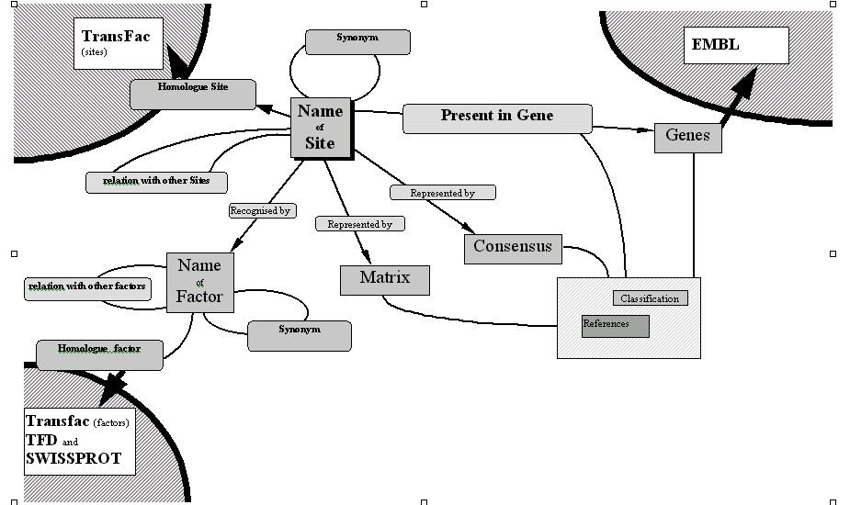

The central node of the database is the ‘name of site’-table, having the most general characteristics on the sites. Furthermore, a table for references is included, as literature is, for now, the most important source of information, and as the sites are organised taking the plant species into account a table for that purpose is provided.
To the central table are linked, the tables ‘consensus’, ‘matrix’ and ‘site present in gene’. The latter being the table for storing specific sites on specific promoter sequences. The promoter sequences are not stored in the database as such but as an accession number in the ‘genes’-table for linking with EMBL, assuring an up to date sequence at all time.
The information on factors, recognising a site can also be stored within the database. Our database has also all the necessary tables to link it to different existing databases, such as TRANSFAC⁵.

Motif Sampling
A first test run of the algorithm was performed on the well defined G-box data set. The initial parameters of the algorithm are weighting vector γ, the motif length, the alignment vector and the background model. Most of the motifs detected by our algorithm corresponded to the G-box consensus sequences as annotated in the database. Only in 6 of the 34 sequences the wrong motif was found. For those motifs either γ_{i} was small or the motif probability itself was small. Moreover, the G-boxes of the corresponding sequences in PlantCARE, were annotated as putative (detected by homology).
By using distinct test runs, the sensitivity of the algorithm towards different initial conditions and the size of the dataset was analyzed. The influence of the initial alignment vector and the weighting vector on the final performance were found to be minor. The most important influence however seems to originate from the choice of an appropriate background model. A background model compiled from a large data set, independent from the set used for motif detection leads to the best results. To this end a background model was derived from the intergenic A. thaliana sequences. If there is no such dataset is available, a background model can be constructed from the input data set. When a good background model is provided, a well-conserved motif can be detected in a data set of limited size (e.g. with no more than 2 sequences).
In the next step the 22 sequences from the light induced set were added to the G-box set. The algorithm is still able to find the G-box motif. In this mixed data set, the ratio of sequences with a high γ is higher in the G-box-containing sequences than in the sequences of the light induced genes. The sequences with a high weight γ are the ones containing a good match with the consensus CACGTG.

Discussion

The database PlantCARE aims at giving a rigorous description of all known cis-acting promoter elements in plants. It is being constructed as such to avoid redundancy. A relational database which takes full advantage of referential links, enables data to be retrieved in many ways allowing for instance to query the database on all the sites present on a promoter, on all the sites occurring in a particular plant species or group, or even on authors who have published on genes having particular functions associated with a specific site occurring in one plant species.
Our implementation of the motif detection algorithm allows detection of the G-box motif in noisy plant datasets. Its enhanced background model constitutes one of the major improvements. So far the algorithm allows detecting one or no occurrence of the motif per sequence. Extensions that would allow retrieving more occurrences of one motif per sequence or multiple motifs are currently under development.

Acknowledgements
Gert Thijs is a research assistant with the IWT; Yves Moreau is a post-doctoral researcher of the FWO; Prof. Bart De Moor is research associate at the FWO and professor extraordinary at the KULeuven. This work is supported by several institutions: 1. The Flemish Government: a. Research Council K.U.Leuven: Concerted Research Action Mefisto-666. b. The FWO projects G.0240.99, G.0256.97, and Research Communities: ICCoS and ANMMM. c. IWT projects: STWW. 2. the Belgian State, Prime Minister's Office - OSTC – a. IUAP P4-02 (1997-2001). 3. Industrial Contract Research: Data4S. The scientific responsibility is assumed by its authors. We would like to thank Patrice Déhais for his help and expertise on database design. Pierre Rouzé is Research Director of INRA (Institut National de la Recherche Agronomique, France).

References

- Bailey T. L. et al. (1995). "The value of prior knowledge in discovering motifs with MEME." Proceedings ISMB 3: 21-9.
- Lawrence C. E. et al. (1993). "Detecting subtle sequence signals: a Gibbs sampling strategy for multiple alignment." Science 262 (5131): 208-14.
- Rombauts S. et al. (1999). "PlantCARE, a plant cis-acting regulatory element database." Nucleic Acids Res. 27 (1): 295-6.
- Thijs G. et al. (1999). "Recognition of gene regulatory sequences by bagging of neural networks.'' Proceedings ICANN’99, 988-993.
- T. Heinemeyer, X. Chen, H. Karas, A. E. Kel, O. V. Kel, I. Liebich, T. Meinhardt, I. Reuter, F. Schacherer and E. Wingender (1999). Expanding the TRANSFAC database towards an expert system of regulatory molecular mechanisms. Nucleic Acids Res 27 (1): 318-22

