A higher-order background model improves the detection by Gibbs sampling of potential promoter regulatory elements in DNA sequences

Gert Thijs¹, Magali Lescot¹, Kathleen Marchal¹, Stephane Rombauts², Bart De Moor¹,
Pierre Rouzé³ and Yves Moreau¹

¹ ESATSISTA/COSIC, KULeuven, Kasteelpark Arenberg 10, 3001 Leuven-Heverlee, Belgium
² Department of Plant Genetics, VIB, UGent, Ledeganckstraat 35, 9000 Gent, Belgium
³ INRA associated laboratory, VIB, UGent, Ledeganckstraat 35, 9000 Gent, Belgium

Email: {gert.thijs,yves.moreau}@esat.kuleuven.ac.be
URL: http://www.esat.kuleuven.ac.be/sista
Tel: +32/16321884
Fax: +32/16321970

Abstract
Motivation: Transcriptome analysis allows to detect and cluster genes that are coexpressed under various biological circumstances. Acknowledging the assumption that coregulated genes share cis-acting regulatory elements, it is worth investigating the upstream sequences controlling the transcription of these genes. To improve the robustness of the Gibbs sampling algorithm to noisy data sets we proposed an extension of this algorithm for motif finding with a higher-order background model.
Results: Data sets with well-described regulatory elements were used to test the influence of the different background models on the performance of the motif detection algorithm. We showed that the use of a higher-order model considerably enhanced the performance of our motif finding algorithm in the presence of noisy data. For Arabidopsis thaliana, a background model based on a set of carefully selected intergenic sequences was constructed.
Availability: Our implementation of the Gibbs sampler called the motif sampler can be used through a web interface: http://www.esat.kuleuven.ac.be/~thijs/Work/MotifSampler.html.
Contact: {gert.thijs,yves.moreau}@esat.kuleuven.ac.be
Keywords: motif detection, Gibbs Sampling, gene regulation, microarray experiments, higher-order background model

Introduction
Recent high-throughput techniques to monitor gene expression levels constitute an important advance in the identification of coexpressed genes (for a review, see Lockhart and Winzeler 2000). The commonly accepted assumption that coregulated genes share similarities in their regulatory mechanism has lead to a major challenge for the computational biologist: defining novel regulatory elements (motifs) in such sets of coexpressed genes (DeRisi et al. 1997; Chu et al. 1998; Spellman et al. 1998; Wolfsberg et al. 1999; Zhang 1999a; van Helden et al. 1998; van Helden 2000). These similarities at transcriptional level imply that the promoter region might contain consensus motifs recognized by the same regulatory proteins. In the upstream regions of such sets of coregulated genes, the common consensus motifs are statistically over-represented as compared with a background set (of non-coregulated genes).
Several methods to search for over-represented motifs in the upstream region of a set of coregulated genes have been developed and tested. These methods can be divided in two major classes: methods based on word counting (Jensen and Knudsen 2000; van Helden et al. 1998; van Helden et al. 2000; Vanet et al. 2000) and methods based on probabilistic sequence models (Bailey and Elkan 1995; Hughes et al. 2000; Lawrence et al. 1993; Liu et al. 1995; Neuwald et al. 1995; Roth et al. 1998; Workman and Stormo 2000). Word counting methods are based on the frequency analysis of oligonucleotides in the upstream sequences. Over-representation is measured by comparing the counted number of occurrences of a word to the expected number of occurrences. A common motif is then compiled by grouping similar words. In the probabilistic methods, the motif model is represented as a position probability matrix and the motif is assumed to be hidden in a noisy background sequence. To find the parameters of such a model, maximum likelihood estimation is used. The most frequent methods to do so are Expectation Maximization (EM) and Gibbs Sampling. EM is a maximum likelihood algorithm to estimate the parameters of a probabilistic model. Gibbs Sampling is a stochastic equivalent of EM. The drawback of these algorithms is that they tend to be sensitive to noise. Noise is due to the presence of upstream sequences in the data set that do not contain the motif. These sources of noise have either an experimental origin or are artifacts of the clustering process and are difficult to avoid.
Sets of coexpressed genes are identified by clustering analysis of data produced by high-throughput profiling techniques (Brazma et al. 2000; Eisen et al. 1998; Zhang 1999b). It is reasonable to assume that sets of coexpressed genes may share some similarities in their regulatory mechanism (i.e., that most of them are coregulated). Since clustering is a predictive method, it is expected that the data sets, compiled by clustering gene expression profiles, contain to some extent noisy sequences.
The large size of the sequences as compared to the size of the motifs is a second source of noise. Parts of the sequence not containing a motif can indeed be considered as noise. This second source of noise obviously depends on the compactness of the genome. For higher eukaryotes, the size of intergenic regions varies considerably between organisms, being much larger on average in humans than in Arabidopsis. Even within the same specie the size of the intergenic region can vary (e.g. by at least 2 orders of magnitude for Arabidopsis, from <10² to >10⁴ (Pavy et al. 1999)). Therefore the influence of the noise can be expected to be reasonably low for bacteria and still limited for lower eukaryotes such as yeast, but more pronounced for higher eukaryotes.
Conceivably, it is very important to have a motif detection algorithm that can cope with this noise and discriminate between motifs that are over-represented by chance and motifs that are biologically functional. An improved background model (model of non coregulated genes) can considerably improve this discrimination.
Most probabilistic models published so far (Bailey and Elkan 1995; Hughes et al. 2000; Lawrence et al. 1993; Liu et al. 1995; Neuwald et al. 1995; Roth et al. 1998) use a simple background model based on the frequency of the nucleotides A, C, G, and T in the data set to represent an intergenic sequence. However, a background model solely based on single nucleotide frequencies might not sufficiently model the complex interrelation. A description of DNA sequences as higher-order Markov chains on the other hand has been used in most of the state-of-the-art gene recognition software to represent coding and non-coding regions (background): Glimmer and the Arabidopsis specific GlimmerA (Delcher et al. 1999), HMMgene (Krogh 1997) and GeneMark.hmm (Lukashin and Borodowsky 1998). In this paper we describe the extension of the Gibbs sampling algorithm with a complex context-dependent background model.
To construct a reliable higher-order background model, a selected data set of intergenic sequences from Arabidopsis was created. The influence of different background models on the robustness of the motif sampler in the presence of noisy data was exhaustively tested. We will describe the construction of the background models and the use of this background model with the Gibbs sampling algorithm. The influence of the extensions was tested on several well-described data sets for which different motifs are documented in Arabidopsis.

Algorithm
Higher-order background model
As stated in the introduction, most of the state-of-the-art gene detection software uses a context dependent model based on a higher-order Markov process to represent DNA sequences. Based on the rationale of these algorithms, the use of such a model to detect motifs in the upstream region of coregulated genes seems a logical decision. Using a context-dependent model of order m means that the probability of finding a nucleotide b at position l in a sequence depends on the m previous nucleotides in the sequence. The probability of the sequence being generated by this background model, B_{m}, is given by:
$$P(S|B_{m})=P(b_{1},…,b_{m})\prod_{l=m+1}^{L}{P(b_{l}|b_{l−1},…,b_{l−m})}$$
The probabilities, $P(b_{l}|b_{l−1},…,b_{l−m})$, are stored in a transition matrix. The construction of the transition matrix of an m^{th}-order background model is based on the counting of all oligonucleotides of length (m+1) in the data set. To compensate for zero occurrences of certain oligonucleotides a pseudocount proportional to the single nucleotide distribution and depending on the size of the data set is added. The number of nucleotides in the sequences determines the weight factor. We choose this weight to be inversely proportional to the square root of the number of nucleotides in the data set. Based on Bayesian statistics, we assume that the more data are available the more we can rely on these data to approximate the true biological model.
The background model can be either constructed based on the input sequences or based on an independent data set of intergenic sequences. The latter approach seems the more sensible one to produce a reliable background model. The quality of the background model depends on the quality of the data set. In this paper a set of carefully selected intergenic sequences from Arabidopsis thaliana is used to construct a reliable background model.

Extension of the motif sampler
Our motif sampler (Thijs et al. 2000) is based on the original Gibbs sampling algorithm previously described by Lawrence (Lawrence et al. 1993). To use the higher-order background models we adapted the motif sampler. The calculation of the background model is done as an initialization step of the algorithm. The background model is computed either from the input sequences, making it useful for any organism, or from the Arabidopsis intergenic data set and is not updated since there is no need to re-estimate the background model at each iteration step of the algorithm. This background model is used in the calculation of the site probabilities, where a site is defined as a subsequence of length W.
The motif of length W is represented with a position probability matrix, θ_{W}, where the entry, q_{i,b}, contains the probability of finding nucleotide b at position i in the motif:
$$θ_{W}=\left[\begin{matrix}q_{1,A} & q_{2,A} & ⋯ & q_{W,A} \\ q_{1,C} & q_{2,C} & ⋯ & q_{W,C} \\ q_{1,G} & q_{2,G} & ⋯ & q_{W,G} \\ q_{1,T} & q_{2,T} & ⋯ & q_{W,T}\end{matrix}\right]$$
For each site x of length W in a sequence, two probabilities are calculated: Q_{x} the probability of site x being generated by the motif model, θ_{W}:
$$Q_{x}=P(\text{Site}|θ_{W})=\prod_{l=1}^{W}{q_{l,\text{bl}}}$$
and P_{x} , the probability of site x being generated by the background model, B_{m}:
$P_{x}=P(\text{Site}|B_{m})=\prod_{l=1}^{W}{P(b_{l}|b_{l−1},…,b_{l−m})}$.
A weight W_{x} is then assigned to each segment x in the sequence
$W_{x}=\frac{Q_{x}}{P_{x}}$
Subsequently the alignment vector of the motif in this sequence is sampled according to the distribution of normalized weights W_{x}. Using this distribution we can find the alignment that maximizes the ratio of the corresponding site probability to the background probability. Now we can formulate the basic algorithm:
- Select the appropriate background model and calculate the background probabilities, P_{x}, of each site x of length W in every sequence. These probabilities are fixed and do not need to be updated during the algorithm.
- Initialize the alignment vector, $A=\left\{a_{k}|k=1…N\right\}$, based on a uniform distribution W_{x}.
- Predictive update: Select a sequence S_{z} and calculate the motif θ_{W} based on the current alignment for all sequence excluding S_{z}.
- Sampling step: Update W_{x} for sequence S_{z} using Q_{x} and P_{x}, as described above. Sample a new position a_{z} from the normalized distribution W_{x}.
- Repeat the algorithm from step 3 until the motif has converged.
To retrieve more motifs an iterative scheme is used. After detecting the first motif, the motif positions in each sequence are masked and the algorithm starts a second round of iterations to detect the next motif.

Parameters
Our algorithm requires 5 parameters to be defined:
- Background model (B_{m}): The background model can be either taken from one of the precompiled models using Arabidopsis thaliana intergenic sequences or computed from the input sequence data, making the motif sampler also usable for organisms other than Arabidopsis thaliana.
- Length (W): The length of the motif is fixed and is user-defined.
- Number of motifs (N): This is the number of different motifs to be searched for in consecutive runs of the algorithm. The positions of the motifs found in the previous runs will be masked.
- Number of copies (C): A motif can have several copies in a sequence. This parameter sets the maximum number of expected copies of a motif in every sequence. If this number is set too high, too much noise will be introduced in the motif model.
- Overlap (O): This parameter defines the maximal allowed overlap between the different motifs.

Data Sets
Intergenic data set
To construct the best possible representation of promoter sequences or intergenic sequences a data set consisting of carefully selected intergenic sequences was constructed, following a previously described rationale to build Araset (Pavy et al. 1999). To define clean intergenic sequences, all complete cDNAs were downloaded through SRS and aligned on BAC sequences. The aligned genes were checked manually by an expert (S. Aubourg, personal communication). Each time the cDNAs matched two consecutive genes on the BAC, the intergenic sequence was extracted. The sequences with a length below 10 kb were then extensively checked for any unannotated potential coding sequences, using BLAST (Altschul et al. 1990) for homology searches and prediction software as EuGène (Schiex et al. 1999). 78 intergenic sequences were retained, representing a total of 156.087 bp. These sequences were added to the 94 intergenic sequences retrieved from Araset, resulting in a data set with 341.248 bp. Figure 1 shows the three different configurations in which neighboring genes can occur. 105 sequences have the first configuration (1) consisting of two genes coding in tandem on the same strand. In this case the intergenic region is expected to contain only one promoter. 38 sequences have the second configuration (2) where both genes are pointing away from each other. In this intergenic region divergent promoters are expected to control transcription. In the last case (containing 29 sequences) the transcription of the two genes is convergent. No promoter regulatory element is expected to occur in the intergenic region. The transition matrix was only built from the intergenic sequences of the classes (1) and (2), which likely contain either one or two promoters.

Data sets for testing
To test the performance of our implementation we constructed several data sets. The data sets are accessible on the web: http://www.plantgenetics.rug.ac.be/~males/Datasets/Data.html.
- Gbox sequences: This set of sequences was extracted from PlantCARE (Rombauts et al. 1999) and contains the upstream region of genes that are known to be regulated by Gbox binding proteins in dicots. The consensus of the Gbox is CACGTG. The position of the Gbox is well defined in this data set. The set contains 33 sequences of 500bp. The G-box (CACGTG) is a well-conserved ubiquitous cis-acting regulatory element found in plant genomes and is bound by the GBF (G-box binding factors) family of bZIP proteins.
- Ibox: This set is also created from entries in PlantCARE and was constructed by selecting the genes that have an Ibox in the upstream region. This set contains 12 sequences of various lengths; ranging between 300 and 1500bp. 10 out of 12 sequences also contain a Gbox. The consensus sequence of an Ibox is GATAAG. Compared to the G-box it is considerably less conserved. Both, G-boxes and I-boxes, play an essential role in light-regulated gene expression (Donald and Cashmore, 1990).
- Light induced: This set contains the upstream region of 28 coexpressed A. thaliana genes. Coexpression was based on the cluster analysis of a microarray experiment (Desprez et al. 1998).
- Random: Set of randomly selected Arabidopsis upstream sequences of at least 150 bp, not described to be involved in light regulation and not containing a known Gbox or Ibox.

Results
Construction of an independent background model
The construction of a Markov process can rely either on the upstream sequences from the input data or from an independent data set. This independent data set consists of a well-defined set of intergenic regions of A. thaliana genes (see Data Sets). It should be noted that the number of nucleotides used to construct the Markov model limits the order of the background model that can be used. Indeed, when a transition matrix of order m is constructed, all oligonucleotides of length (m+1) are counted. The number of possible different oligonucleotides equals 4^{m+1} and increases exponentially with m. The data set used for the construction of the background model should, under the assumption of an equal nucleotide distribution at least contain 4^{m+1} different base pairs to have a single count for each nucleotide. In reality the assumption of equal nucleotide distribution does not hold and a much larger data set will be needed. When an oligonucleotide does not occur in the data set, it will be replaced by a pseudocount. When the order of the background is too high relative to the size of the data set on which this background model was based, less frequent motifs will be encountered which deteriorate the motif model. Following this reasoning the improvement of using a Markov chain background model will be more explicit when its construction is based on a large data set (such as the one used in this study).

Ibox / G-box
In a first test we used a small test set of 12 sequences upstream of translation start. The sequences were chosen in such a way that there were 2 known motifs present: a less conserved Ibox (GATAA) that occurs in all 12 sequences and a well-conserved Gbox (CACGTG), that is only present in 10 sequences (see Data Sets). Seven different background models were used: order 1, 2 and 3 either based on the data set itself or the intergenic data set and the single nucleotide frequency. Because of the stochasticity of our algorithm each test was repeated 10 times to find motifs that consistently appear. When performing repeated runs of the same test those re-occurring motifs are likely to represent either strong local optima or the global optimum.
In the first set of tests we searched for 5 different motifs with a length of 8bp. In the second test we increased the number of different motifs to 10, to check if this could contribute to a higher detection rate of the motif by the motif sampler. The results of the experiments are summarized in Table 1. The performance was evaluated by counting the number of times a motif consensus (either G-box or I-box) was detected in the different runs of a test.
The results show that the use of a higher-order background model considerably improved the detection rate of the G-box sequences. Looking for more motifs only increased the performance of the algorithm in the presence of a single nucleotide frequency model. This indicates that in the presence of a single nucleotide frequency model the G-box is a weaker motif. For the I-box however, both the effects of using a higher-order model or looking for more motifs were marginal. Because of its weak degree of conservation and its similarity to the background (AT-rich), it is much more difficult for the algorithm to find the I-box. These tests also show that the order of the background model should be chosen with great care and consideration.

Influence of noisy sequences
To test the influence of the complex background model on the robustness of the motif sampler in the presence of noise, different tests were performed. The previous tests showed that the third-order background model has abetter performance than the other higher-order background models. Therefore in the next set of exhaustive tests only the single nucleotide and the third-order background model are compared.
In this set of tests we started with a data set of 33 genes (G-box data set, see Data Sets). In subsequent tests, the number of noisy sequences added to the G-box data set was progressively increased (10 at the time). The set of noisy sequences, from which each time 10 sequences were sampled, consisted of a random mixture of the light induced (Desprez et al. 1998) and random data sets (see Data Sets). All parameters of the motif sampler algorithm were kept fixed except for the order of the background model (we tried either single nucleotide frequency, third-order Markov model computed from the input data or third-order Markov model computed from the intergenic data set). In each test we searched for 10 different motifs with a length of 8bp. Again as in the previous tests, each test was repeated 10 times.
To evaluate the results we checked in which runs the G-box consensus CACGTG was detected. Since the motif sampler can get stuck in a shifted local optimum, motifs starting with ACGTG or ending in CACGT were also considered as G-box consensus. Based on this definition of the G-box sequence, we calculated the number of times the G-box was found in each test (group of 10 runs). Figure 2 describes the behaviour of the algorithm in the presence of an increasing number of noisy sequences for different background models. The third-order background model clearly outperforms the single nucleotide background model. With the single nucleotide model, the algorithm only detects the G-box consensus in a small number of runs even in the presence of only a limited number of noisy sequences. Both higher-order background models can find the G-box consensus in the presence of a large number of noisy sequences. To further validate the outcome, the positions of the G-box motifs predicted by the algorithm were compared with the positions of G-box of the documented 33 G-box sequences. Three different possibilities can be distinguished:
- The predicted motif is located at the same position as the known G-box motif (true positive).
- The algorithm could not detect a motif although the presence of a motif was described (false negative).
- A potential G-box motif detected by the algorithm is located at a different position than the described G-box (ambiguous case).
In the last case, the predicted position might represent a yet undetected G-box and is therefore inconclusive. Figure 2a shows the average number of correctly predicted motif positions. The calculation was based for each experiment only on the runs in which a G-box consensus was detected. Figure 3a demonstrates that the number of correctly predicted motifs (true positives) decreases with increasing noise, as expected. However, the order of the background model does not interfere drastically with the number of correctly predicted motifs. On average, approximately 70% of the G-boxes are correctly predicted. This indicates that, if a motif is detected, it is in 70% of the cases the right motif, irrespective of the background model. The background model does not improve the performance of the algorithm in making correct predictions. However, the influence of the complex background model on the robustness and performance of the algorithm in the presence of noise becomes obvious when taking into account the number of missed true positives. Figure 3b depicts the average number of sequences in which the algorithm could not predict the right G-box motif (false negatives). This number of false negatives consists of all the sequences in a run in which the algorithm could not detect a G-box consensus although a G-box was described in the sequence. Figure 2b shows that the more noise is added to the data set, the higher the percentage of missed G-boxes. Moreover, this effect is considerably more pronounced for the single nucleotide background model than for the third-order background model. The third-order model based on the set of intergenic sequences performs better than the third-order model based on the input data.
We usually observed during the tests that when using a third-order background model, the algorithm retrieved the G-box consensus as one of the first motifs, while this was not the case for the single nucleotide model. The rapid convergence of the algorithm to the G-box indicates that it is a very stable motif in the presence of a third-order model. This was further corroborated by the fact the G-box motif was in these cases also the motif with the highest log-likelihood score.

Discussion
We aimed at improving the performance of a probabilistic implementation of a motif finding algorithm in the presence of noisy data. To this end the existing algorithm was extended with a more complex background model. We anticipated that the description of the background sequences as single nucleotide frequencies was not sufficient to capture the complex information in the inherently non-random sequence code. Therefore we used Markov models of higher-order to represent the intergenic sequences in DNA. We adapted the original Gibbs Sampling algorithm in such a way that we can incorporate the higher-order background model to update the probabilities of finding a motif at a certain position in the sequence. Since random sequences do not bear the necessary information for the right expression of genes in their developmental or functional frame, a set of carefully selected intergenic regions was used to construct a higher-order background model for Arabidopsis thaliana. As was shown in the Results section the quality and the size of this intergenic data set determine the reliability of the order of the model. This number also puts a lower bound on the number of bases needed to construct a reliable transition matrix.
The behaviour of the algorithm in the presence of an increasing amount of noisy data has extensively been tested. The use of a third-order model was shown to be considerably more robust than a single nucleotide background. The overall recovery of the motifs was higher in the presence of a higher-order model, though the number of correctly predicted motifs was only marginally affected by the complexity of the background model. It has been shown that this positive effect of the background model is more pronounced when looking for a motif that considerably differs from the background.
Future work will concentrate on the improvement of the Arabidopsis thaliana background model through extending the intergenic data set and also by using interpolated Markov chains to augment the significance of the transition matrix. Focus will be on the automatic selection of the best background model.

Acknowledgments
Gert Thijs is research assistant with the IWT; Yves Moreau is a post-doctoral researcher of the FWO; Prof. Bart De Moor is a full time professor at the KULeuven; Pierre Rouzé is Research Director of INRA (Institut National de la Recherche Agronomique, France). This work is partially supported by: 1. IWT project: STWW-980396; 2. Research Council KULeuven: GOA Mefisto-666; 3. FWO projects: G.0240.99 and G.0256.97; 4. IUAP P4-02 (1997-2001); 5. Industrial Contract Research: Data4s. The scientific responsibility is assumed by its authors.

References
Altschul, S., Gish, W., Miller, W., Myers, E.W., and Lipman, D.J. 1990. Basic local alignment search tool. J. Mol. Biol. 215: 403-410.
Bailey, T.L., and Elkan, C. 1995. Unsupervised learning of multiple motifs in biopolymers using expectation maximization. Machine Learning 21: 51-80.
Brazma, A., and Vilo, J. 2000. Gene expression data analysis. FEBS Letters 480: 17-24.
Bucher, P. 1999. Regulatory elements and expression profiles. Curr. Opin. in Structural Biology 9: 400-407.
Chu, S., DeRisi, J., Eisen, M.B., Mulholland, J., Botstein, D., Brown, P.O., and Herskowitz, I. 1998.The transcriptional program of sporulation in budding yeast. Science, 282: 699-705.
Delcher, A.L., Harman, D., Kasif, S., White, O., and Salzberg, S.L.. 1999. Improved microbial gene identification with glimmer. Nucl. Acid Research 27(23): 4636-4641.
DeRisi, J.L., Iyer, V.R., and Brown, P.O. 1997. Exploring the metabolic and genetic control of gene expression on a genomic scale. Science, 278: 680-686.
Desprez, T., Amselem, J., Caboche, M., and Hofte, H. 1998. Differential gene expression in Arabidopsis monitored using cDNA arrays. Plant Journal 14(5): 643-52.
Donald, R.G.K., and Cashmore, A.R. 1990. Mutation of either G box or I box sequences profoundly affects expression from the Arabidopsis rbcS-1A promoter. EMBO J. 9(6): 1717-1726.
Eisen, M. B., Spellman, P. T., Brown, P. O., and Botstein, D. 1998. Cluster analysis and display of genomewide expression patterns. Proc. Natl. Acad. Sci. 95: 14863-14868.
Hughes, J. D., Estep, Preston W., Tavazoie, S., and Church, G.M. 2000. Computational identification of cisregulatory elements associated with groups of functionally related genes in Saccharomyces cerevisiae. J. Mol. Biol. 296: 1205-1214.
Jensen, L.J., and Knudsen, S. 2000. Automatic discovery of regulatory patterns in promoter regions based on whole cell expression data and functional annotation. Bioinformatics 16(4): 326-333.
Krogh, A., 1997. Two methods for improving performance of an HMM and their application for gene finding. In Proceedings of ISMB'97.
Lawrence, C.E., Altschul, S.F., Boguski, M.S., Liu, J.S., Neuwald, A.F., and Wootton, J.C. 1993. Detecting subtle sequence signals: a Gibbs sampling strategy for multiple alignment. Science 262: 208-214.
Liu, J.S., Neuwald, A.F., and Lawrence, C.E. 1995. Bayesian models for multiple local sequence alignment and Gibbs sampling strategies. JASA 90(432): 1156-1170.
Lockhart D.J., and Winzeler, E.A. 2000. Genomics, gene expression and DNA arrays. Nature 405:827-836.
Lukashin, A.V., and Borodowsky, M. 1998. GeneMark.hmm: new solutions for gene finding. Nucl. Acid Research 26: 1107-1115.
Neuwald, A.F., Liu, J.S., and Lawrence, C.E. 1995. Gibbs motif sampling: detection of bacterial outer membrane protein repeats. Protein Science 4: 1618-1632.
Pavy, N., Rombauts, S., Déhais, P., Mathé, C., Ramana, D.V.V., Leroy, P., and Rouzé, P. 1999. Evaluation of gene prediction software using a genomic data set: Application to Arabidopsis thaliana sequences. Bioinformatics 15: 887-899
Rombauts, S., Déhais, P., Van Montagu, M., and Rouzé P. 1999. PlantCARE, a plant cisacting regulatory element database. Nucl. Acid. Research 27: 295-296.
Roth, F. P., Hughes, J. D., Estep, P. W., and Church, G. M. 1998. Finding DNA regulatory motifs within unaligned noncoding sequences clustered by whole genome mRNA quantitation. Nature Biotechnology 16: 939-945.
Schiex, T., Moisan, A., Duret, L., and Rouzé, P. 1999. EuGène: a simple yet effective gene finder for eukaryotic organisms (Arabidopsis thaliana). In Proc. of 2nd Georgia Tech conference on Bioinformatics, Atlanta.
Spellman, P.T., Sherlock, G., Zhang, M.Q., Iyer, V.R., Anders, K., Eisen, M.B., Brown, P.O., Botstein, D., and Futcher, B. 1998. Comprehensive identification of cell cycle-regulated genes of the yeast Saccharomyces cerevisiae by microarray hybridization. Mol.Biol.Cell, 9: 3273-3297.
Thijs, G., Marchal, K., Lescot, M., Rombauts, S., De Moor, B., Rouzé, P., and Moreau, Y. 2000. A Gibbs Sampling method to detect over-represented motifs in upstream regions of coexpressed genes. Recomb 2001, Accepted.
van Helden, J., André, B., and ColladoVides, L. 1998. Extracting regulatory sites from upstream region of yeast genes by computational analysis of oligonucleotide frequencies. J. Mol. Biol. 281:827-842.
van Helden, J., Rios, A.F., and ColladoVides, J. 2000. Discovering regulatory elements in noncoding sequences by analysis of spaced dyads. Nucl. Acid Research 28(8): 1808-1818.
Vanet, A., Marsan, L., Labigne, A.., and Sagot, M.F. 2000. Inferring regulatory elements from a whole genome. An analysis of Helicobacter pylori sigma(80) family of promoter signals. J. Mol. Biol. 297(2): 335-353.
Wolfsberg, T.G., Gabrielian, A.E., Campbell, M.J., Cho, R.J., Spouge, J.L., and Landsman, D. 1999. Candidate regulatory sequence elements for cell cycle-dependent transcription in Saccharomyces cerevisiae. Genome Res., 9: 775-792.
Workman, C.T., and Stormo, G.D. 2000. ANNSPEC: a method for discovering transcription binding sites with improved specificity. In: Pacific Symposium on Biocomputing 2000.
Zhang, M.Q. 1999a. Promoter analysis of coregulated genes in the yeast genome. Comput.Chem., 23: 233-250.
Zhang, M.Q., 1999b, Large-scale gene expression data analysis: a new challenge to computational biologist. Genome Research 9: 681-688.

Table 1 Number of times the I-box and G-box consensus was found in 10 runs when searching for 5 or 10 motifs.

Figure 1 Representation of the three different configuration of the intergenic region in DNA. The genes are represented with an arrow and the core promoter for each gene is indicated with an oval box. (1) The two genes are pointing in the same direction and there is one core promoter in the intergenic region. (2) Two genes are pointing in the opposite directions and the intergenic region contains the two core promoters. In the last case (3) the genes are pointing towards each other and in the intergenic region there is no core promoter present.

Figure 2 Total number of times the G-box consensus is found in 10 runs. The horizontal axis shows the number of noisy sequences added to the G-box data set.

Figure 3 (a) Average number of correctly predicted G-box positions. This number is based on comparison of the described G-box positions and the predicted positions of the G-box motif in all the runs where a G-box consensus was found. (b) Average percentage of wrongly classified motifs. This number is based the number of sequences that are indicated as not having a G-box although a G-box was documented (including the runs where no G-box consensus is found).

Table 1
 | Data set  order 3 | Data set order 2 | Data set  order 1 | Single  Nucleotide | Intergenic  order 1 | Intergenic order 2 | Intergenic order 3
5 Motifs
I-box Consensus | 5/10 | 0/10 | 5/10 | 6/10 | 6/10 | 1/10 | 5/10
G-box Consensus | 10/10 | 6/10 | 2/10 | 2/10 | 6/10 | 5/10 | 10/10
10 Motifs
I-box Consensus | 8/10 | 2/10 | 5/10 | 7/10 | 7/10 | 4/10 | 6/10
G-box Consensus | 10/10 | 7/10 | 3/10 | 5/10 | 6/10 | 10/10 | 10/10

Figure 1
Gene
Gene
Intergenic
Region
Core Promoter
3
2
1

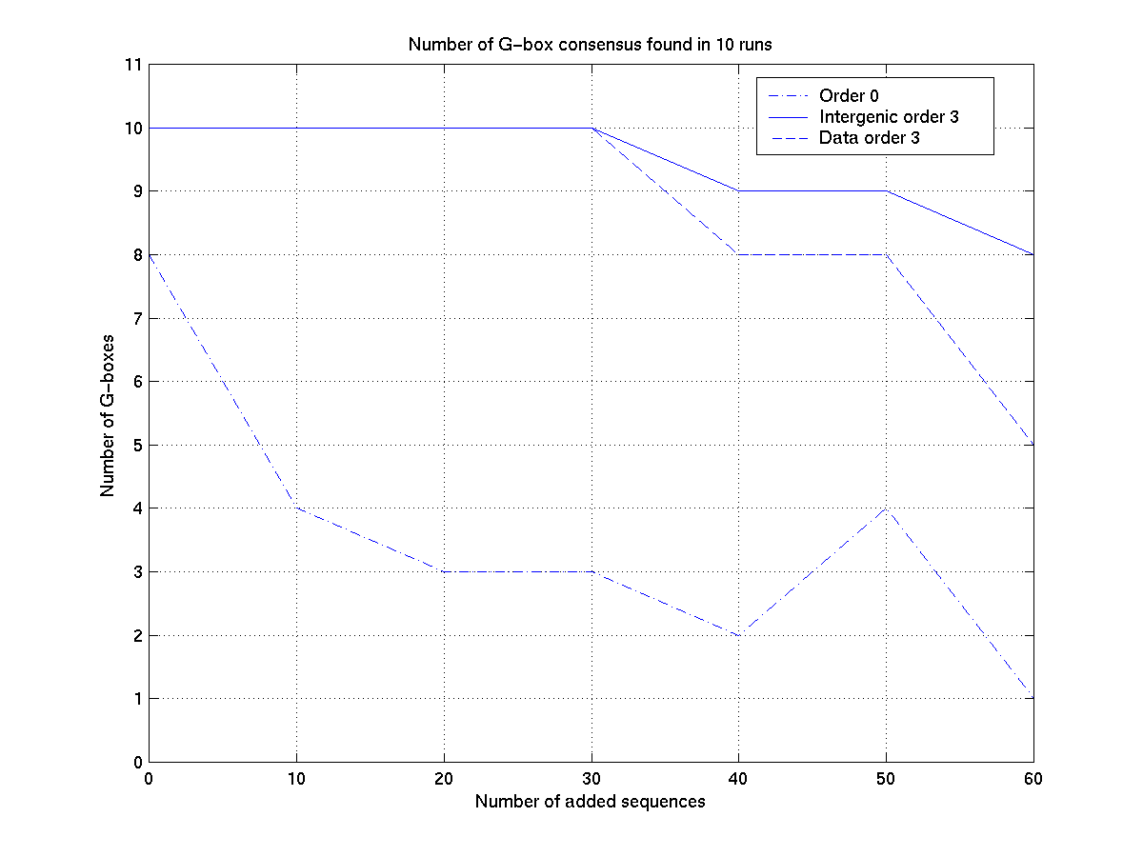
Figure 2

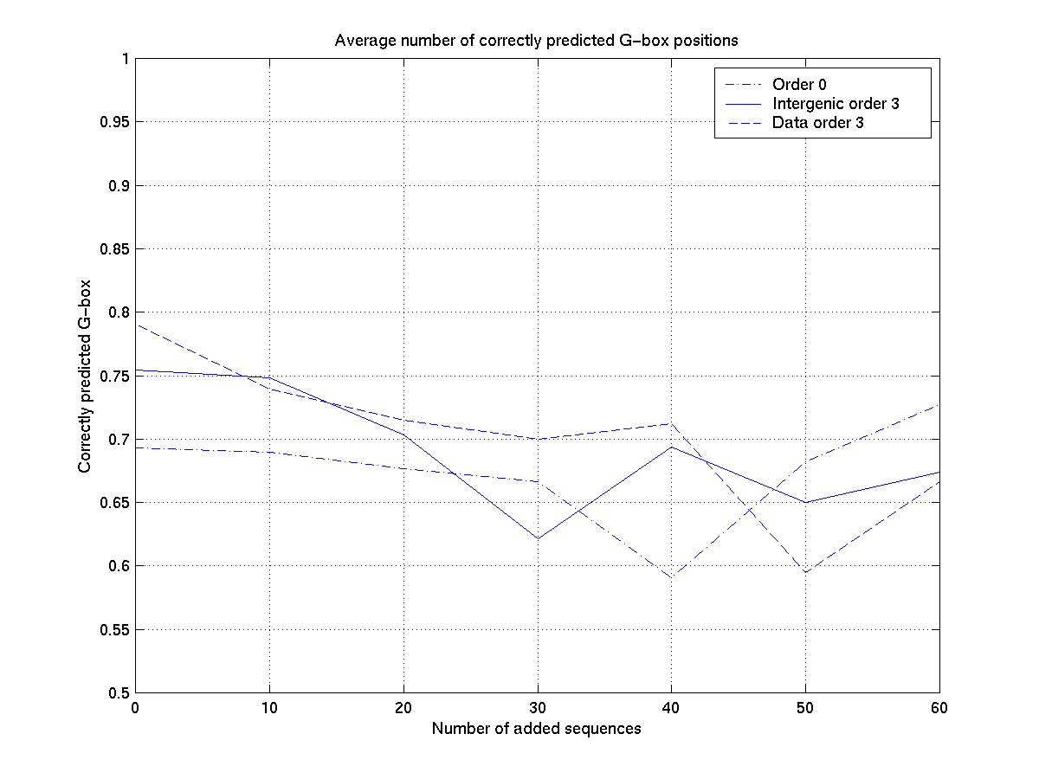
Figure 3a
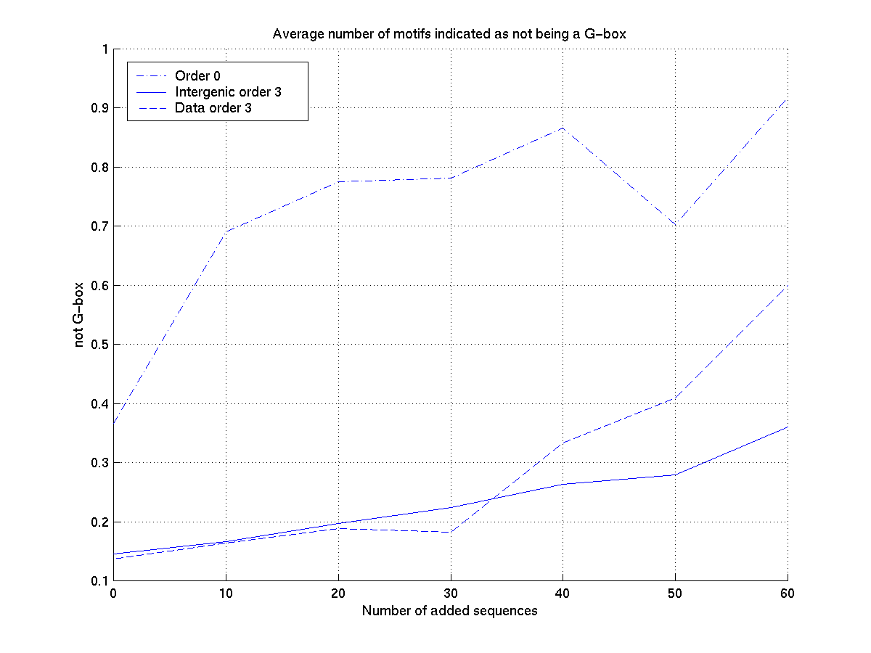
Figure 3b

